**Đề**

**Có thể trùng nhiều → chỉ thêm câu nào trùng → làm theo form để thêm text để search câu nào trùng**

**fuoverflow**

# Đề 1: [PMG201c_FE_SU23_112009](https://fuoverflow.com/threads/pmg201c_fe_su23_112009.646/)(Phát)

# Đề 2: [PMG201c_SU24_2_30201](https://fuoverflow.com/threads/pmg201c_su24_2_30201.2575/)(Hải)(v) Đề 3:[PMG201c_SU24_1_93084](https://fuoverflow.com/threads/pmg201c_su24_1_93084.2527/)(Khang) Đề 4: [PMG201_TE2_SU23_321426](https://fuoverflow.com/threads/pmg201_te2_su23_321426.676/)(Trường) Đề 5:[PMG201c_FE_FA23_172015](https://fuoverflow.com/threads/pmg201c_fe_fa23_172015.1189/)(Hải)(v) Đề 6:[PMG201c_RE_FA23_684554](https://fuoverflow.com/threads/pmg201c_re_fa23_684554.1235/)(Phát)

# Đề 7:[PMG201c_FESP24_756175](https://fuoverflow.com/threads/pmg201c_fesp24_756175.1814/)(Truong)

# Đề 8: [PMG201c_RESP24_534444](https://fuoverflow.com/threads/pmg201c_resp24_534444.1862/)(Hải)(v)

# 

Bài Làm :

Đề 1: SU23 (Phát)

**Q2: Being prepared to do a complete job of developing and finalizing the scope baseline requires that you have done a thorough and timely job of identifying and analyzing stakeholders, and of collecting requirements. The development 1 of the scope baseline can best be described as involving:**

  
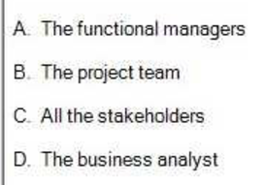   
B. The project team

**Q4. Which one of these is not the major source of conflict that a project manager may influence?**  


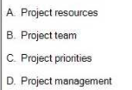  
D. Project management

**Q5. If "develop online modules" needs to finish**

**before "review online modules" can finish, that is called:**  


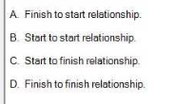

D. Finish to finish relationship

Q6. True or False: Project quality focuses on the goods and services.



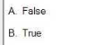  
A. False

Q9. **The following table is an activity list that includes the duration and predecessor for a series of project activities. What is the duration of the critical path?**

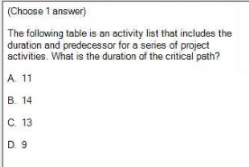

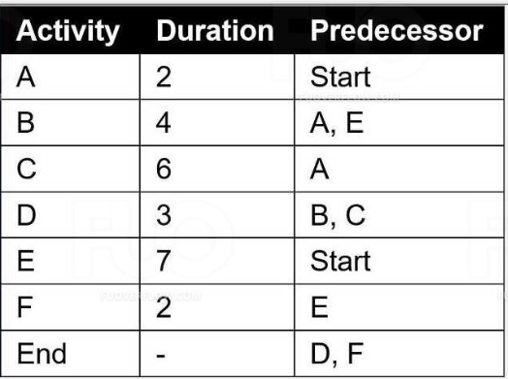  
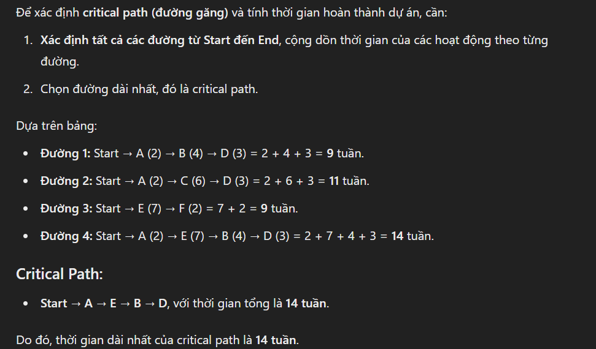

**B. 14**

Q12. In a projectized organization, team members *can* be assigned to the project full-time.

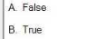 **A. False**

Q14. Your project has a team of which consists of yourself, a tester, five developers, and a communicator. How many communication channels on your team?  


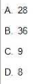

[n *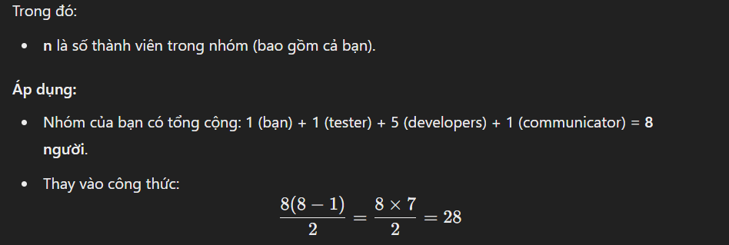 (n-1)] / 2= [8*(8-1)]/2 = 28  
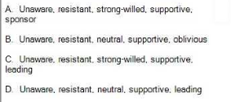

A. 28

Q15. Which of the following is NOT the advantages of top-down estimating?



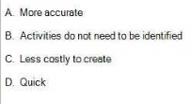

A. More accurate

Q20. Identify the five engagement levels of stakeholders:

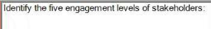

D. Unaware, resistant, neutral, supportive, leading

Q22. Which of the following is NOT the output of Plan Scope Management process? (Choose 2 answers)



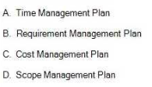  
  
A. Time Management Plan

C. Cost Management Plan

Q23. Which one is not mentioned explicitly in the three components of the triple constraints?  


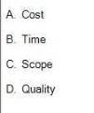  
D. Quality

Q24. The team is helping the project manager to estimate activities on their project. There are several activities they need to estimate that have not been previously done by the company. What is the best method of estimating these activities?

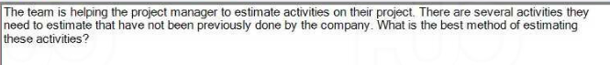

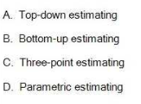  
A. Top-down estimating

Q26. Your sponsor informs you that you must receive local government approval of your proposed building design before you can begin construction of your building. This dependency is:  


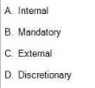  
C. External

Q28. To calculate early start (ES) of an activity which has more than one immediate predecessors, you will



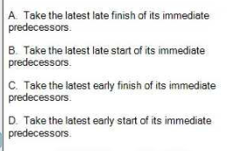  
C. Take the latest early finish of its immediate predecessors.

Q30. True or False: Quality management is the job done by project manager himself/herself to determine quality policies, objectives, and responsibilities so that the project will satisfy the needs for which it was undertaken



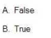

A. False

Q33. True or False: The Crashing is the approach to re-plan the work and try to perform more overlapping sequential activities to be in parallel.



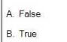  
A. False

Q35. The purpose of project risk management is to:

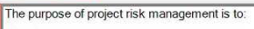

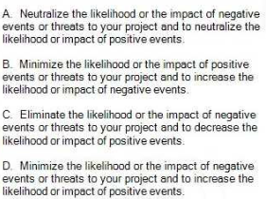  
D. Minimize the likelihood or the impact of negative events or threats to your project and to increase the likelihood or impact of positive events.

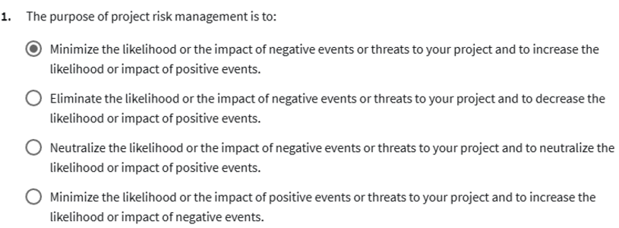

Q36. True or False: You should compare your project performance against the performance measurement baseline to look for potential changes in the project.  


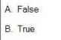  
B. True

Q38. Which one of these is correct view of conflict?  


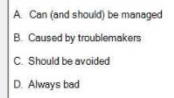

A. Can (and should) be managed

Q41. True or False: The Project Budget is equal to only the Cost Baseline budget.  
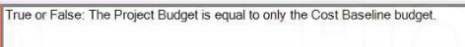

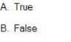  
B. False

Q42. If the response you choose is to accept a risk, this means that:



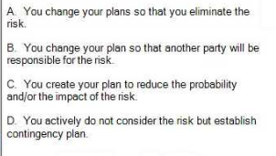  
D. You actively do not consider the risk but establish contingency plan.

Q43. To ensure control over the incidence and frequency of change, the project manager establishes a:



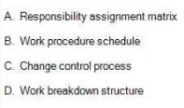

C. Change control process

Q45. You have a project to build a new fence in the shape of a square. Each side of the square is planned to take one day to complete, with a budget of $1,000 per side. The sides are constructed sequentially, one after another.

Today is the end of Day 3.

Using the provided project status chart, calculate the project's current Cost Variance (CV).

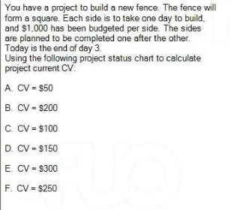

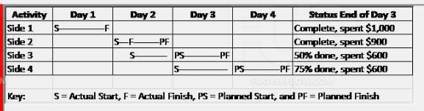

D. CV = $150

Q46. A project manager has little project experience, but she has been assigned as the project manager of a new project. Because she will be working in a matrix organization to complete her project, she can expect communications to be  


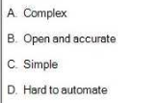  
A. Complex

Q47. Which project management process group generally takes the most project time and resources?



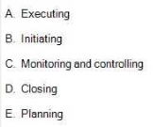  
A. Executing

Q49. A cost can be either direct or indirect. Which of the following statements are correct (choose 2 answers)?  


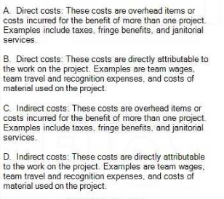  
B. Direct costs: These costs are directly attributable to the work on the project. Examples are team wages, team travel and recognition expenses, and costs of material used on the project.

C. Indirect costs: These costs are overhead items or costs incurred for the benefit of more than one project. Examples include taxes, fringe benefits, and janitorial services.

Đề 2: SU24_2(Hải)

Q1: A market demand, a business need, and a legal requirement are examples of:  
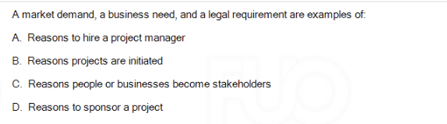  
B. Reasons projects are initiated

Q2: A project manager is trying to complete a software development project, but cannot get enough attention for the project. Resources are focused on completing process-related work, and the project manager has little authority to assign resources. What form of organization must the project manager be working in?

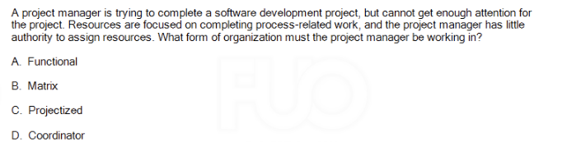  
A. Functional

Q3: A project manager's primary responsibility is to deliver the product of the project within project constraints.Actions taken and changes made to the benefit of one constraint could negatively affect another. Which of the following best describes the major constraints on a project?

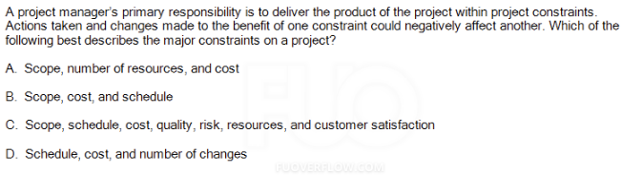

C. Scope, schedule, cost, quality, risk, resources, and customer satisfaction

Q4: Which of the following best describes a project management plan?

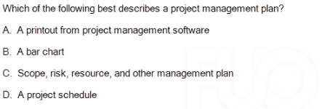

C. Scope, risk, resource, and other management plan

Q5:

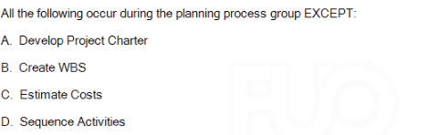

A. Develop Project Charter

Q6. True or False: The Project Charter is a document issued by the project initiator or sponsor that formally authorizes the existence of a project. It provides the project manager with the authority to apply organizational resources to project activities.

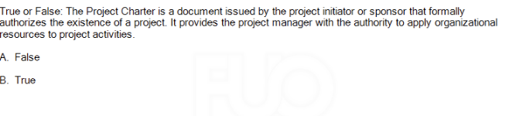

B. True

Q7. Scope creep results in all of the followings, except:

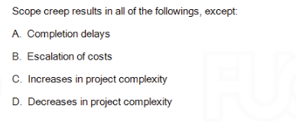

D. Decreases in project complexity

Q8. True or False: In the context of a project, change is always a bad thing.

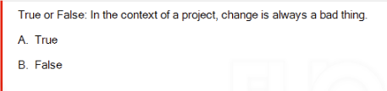

B. False

Q9. During executing, the project manager determines that a change is needed to material purchased for the project. The project manager calls a meeting of the team to plan how to make the changes. This is an example of:

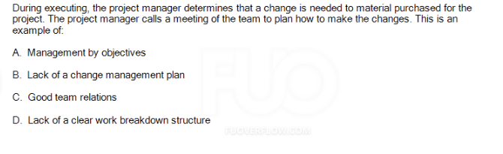

B. Lack of a change management plan

Q10. Company procedures require the creation of a lessons learned register. Which of the following is the best use of lessons learned?

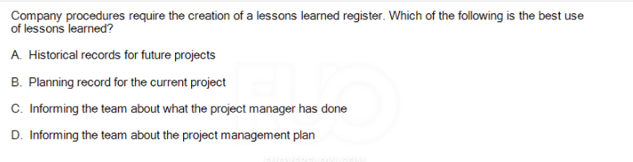  
A. Historical records for future projects

Q11. Should the Project Scope Statement document include?

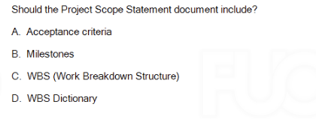

A. Acceptance criteria

Q12.As you plan your project, the sponsor informed you that all team members will be assigned to your project for at most 50% of their available time. This is an example of:

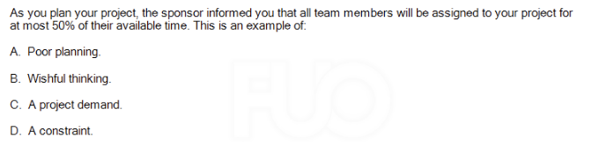

D. A constraint.

Q13. A new project manager has asked you for advice on creating a work breakdown structure. After you explain the process to her, she asks you what software she should use to create the WBS and what she should do with it when it is completed. You might respond that the picture is not the most valuable result of creating a WBS. The most valuable result of a WBS is:

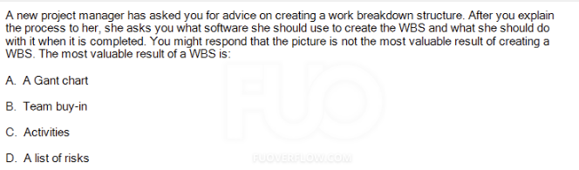

B. Team buy-in

Q14. A project manager may use each of their work packages.

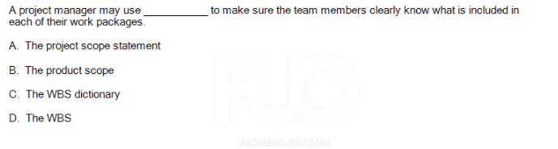

C. The WBS dictionary

Q15. All of the following are inputs to estimating activity durations except:

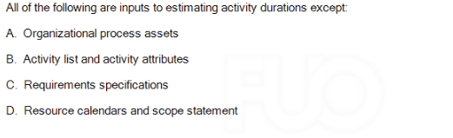

C. Requirements specifications

Q16. True or False: Project Manager should consider using milestones for high level reporting.

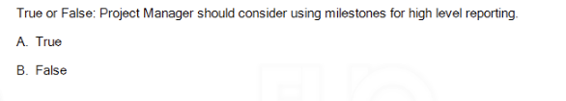

A. True

Q17. Your team member informs you that the test system must be refreshed with your test data before testing can begin. This dependency is:

C. Mandatory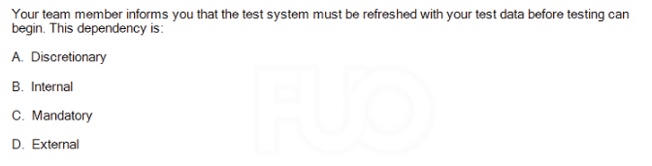

Q18. True or False: If "review online modules" needs to begin before "develop online modules" can finish, that is called a start to finish relationship.

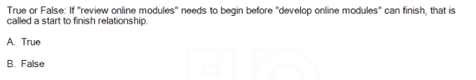

B. False

Q19. To calculate late finish (LF) of an activity which has more than one successor, you will

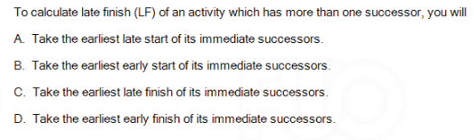

A. Take the earliest late of its immediate successors

Q20. True or False: The critical path is made up by all zero float activities (activities have floats equal to zero) in the project network diagram.

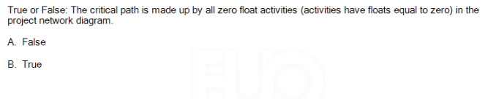

B. True

Q21. True or False: The Backward Pass is used through the activities to determine the critical path & available float of the project.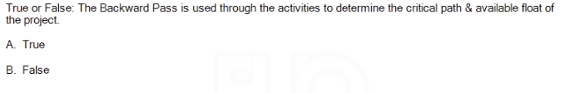

A. True

The Backward Pass is used in project scheduling to calculate the late start (LS) and late finish (LF) times for each activity. This helps determine the critical path (activities with zero float) and the available float (slack time) for non-critical activities in the project. The backward pass starts from the project's end date and moves backward through the network diagram.

Q22. True or False: The Fast Tracking is the approach to add more resources (labor, overtime, etc.) into the activities to reduce their durations.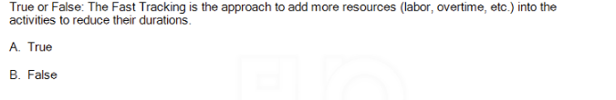

B. False

Q23. Which of the following is NOT the disadvantages of top-down estimating?

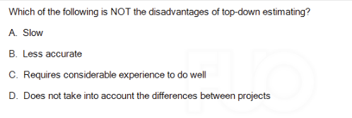

A. Slow

Q24. A team member tells you that her work is too creative to provide you with a fixed single estimate for the activity. You both decide to use the average labor hours (from past, similar projects) to develop a prototype.This is an example of which of the following?

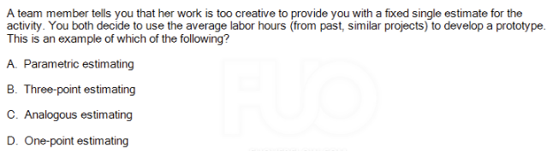

A. Parametric estimating

Parametric estimating involves using historical data or established metrics (such as average labor hours from past similar projects) to estimate the resources required for a project. In this case, the team member is using past experience (average labor hours) to estimate the time or resources needed to develop a prototype, which aligns with parametric estimating

Q25. True or False: Using top-down estimating techniques when the detail is available and the accuracy is needed. 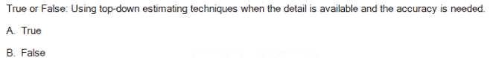

B. False

Q26. True or False: The S-Curve depicts the relationship between the cost baseline budget and the schedule because it shows the planned cost baseline budget across the planned project timeline.

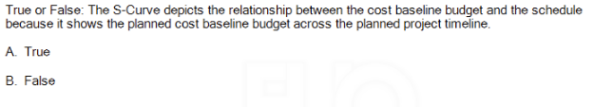

A. True

Q27. True or False: Earned value integrates schedule, budget and quality and uses monetary values to assess project status.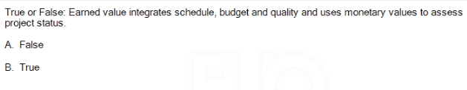

A. False

Earned Value Management (EVM) integrates schedule and budget, but it does not directly incorporate quality into its calculations. EVM focuses on assessing project performance by comparing the planned value (PV), earned value (EV), and actual cost (AC). These metrics are used to evaluate the project's cost and schedule performance, but not its quality. Therefore, the statement is False.

Q28. The discipline of quality management complements the discipline of project management. Both recognize all but one of the following:

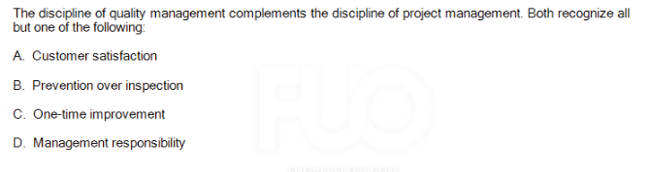

C. One-time improvement

Q29. True or False: Product quality focuses on the project management processes used to meet project

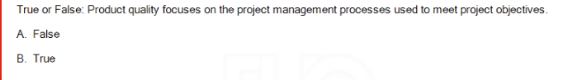

A. False

Q30. The Process Improvement Plan is:

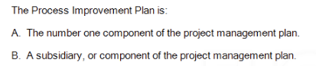

B. A subsidiary, or component of the project management plan.

Q31. True or False: Performing quality assurance within the context of a project involves applying the planned,systematic quality activities to ensure that the project correctly employs all processes needed to meet project objectives and product requirements.

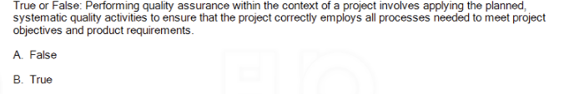

B. True

Q32.True or False: Your role as the project manager during quality control is to work with a representative of quality control department who will create a test plan and test cases which will be used to test the product you are creating in order to prevent defects from reaching your customer.

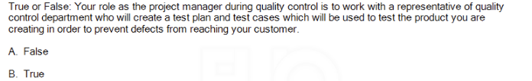

**A. False**

**Q33. True or False: The term resources only refers to people, it does not include money or materials or equipment.**

**view of í**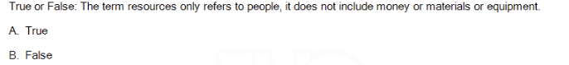

**B. False**

**X**

**Q34. Which one of these is the correct view of conflict?**

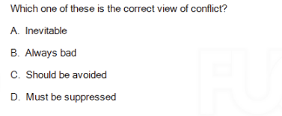

**A. Inevitable**

**Conflict is often considered inevitable in projects and teams because differing opinions, goals, or working styles will naturally arise. However, it is not necessarily negative and can be managed constructively. Conflict can lead to better solutions, innovation, and team development when addressed appropriately. Therefore, viewing conflict as inevitable is the most accurate perspective.**

**Q35. Which one of these is an example of role conflict:**

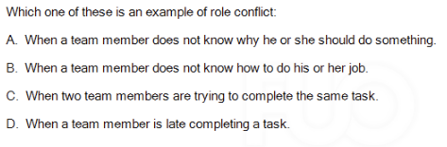

**C. When two team members are trying to complete the same task.**

**Q36.**

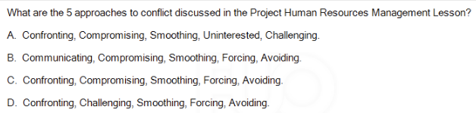

**C. Confronting, Compromising, Smoothing, Forcing, Avoiding.**

**Q37.**

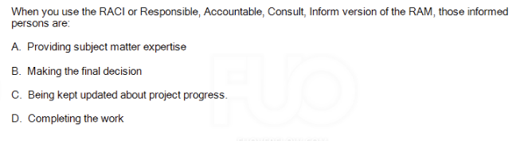

**those informed persons are -> C. Being kept updated about project progress.**

**those who are responsible are-> D. Completing the work**

**Q38. True or False: Effective project communication management creates a bridge between stakeholders based on a shared understanding of the project and the ongoing sharing of information needed for its success.**

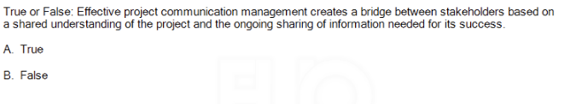

**A. True**

**Q39. Downward communication is communication to/from:**

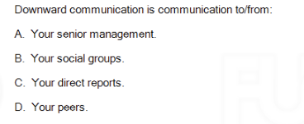

**Downward communication -> C. Your direct reports.**

**Upward communication -> A.Your senior management**

**Q40. Which one is the correct matching of communication methods and the explanations?**

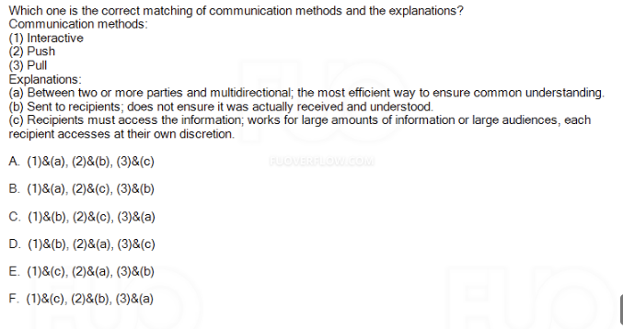

**A. (1)&(a), (2)&(b), (3)&(c)**

**Explanation:**

* **Interactive (1): This involves communication between two or more parties with multidirectional flow, ensuring a common understanding (e.g., meetings, video conferences).**
* **Push (2): Information is sent to recipients, but it does not ensure it is received or understood (e.g., emails, memos).**
* **Pull (3): Recipients must access the information at their discretion, which works well for large amounts of information or large audiences (e.g., websites, document repositories).**

**Q41. True or False: Performance reporting aims to inform stakeholders the good achievements of the project's objectives weekly or monthly.**

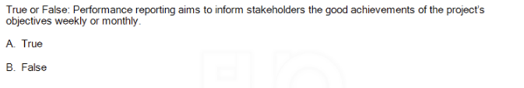

**B. False**

**Explanation: Performance reporting is not solely about informing stakeholders about good achievements. It is about providing a comprehensive view of the project's performance, including progress, risks, issues, and any deviations from the plan, regardless of whether the results are positive or negative. This reporting typically occurs at regular intervals, such as weekly or monthly, and aims to ensure transparency and keep stakeholders informed about all aspects of the project.**

**Q42. True or False: A positive risk is a threat; a negative risk is an opportunity.**

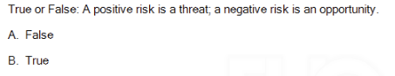

**A. False**

**Q43. All of the following tools and techniques can be valuable in risk identification, EXCEPT:**

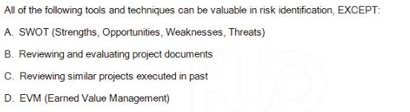

**D. EVM (Earned Value Management)**

**Explanation: EVM is a tool used for measuring project performance, specifically in terms of cost and schedule, rather than for risk identification. It helps track the progress of the project against the planned performance but does not directly contribute to identifying risks.**

**Q44. If the response you choose is to mitigate a risk this means that:**

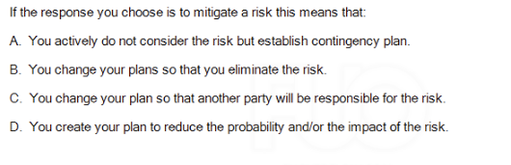

**D. You create your plan to reduce the probability and/or the impact of the risk.**

**Explanation: Mitigating a risk means taking proactive steps to reduce the likelihood of the risk occurring or minimizing its impact if it does happen. This involves developing strategies to lower the risk’s severity or probability**

**Q45. During a risk brainstorming session, a team member identifies a risk. This particular risk does not seem to belong to any of the categories in you Risk Breakdown Structure (RBS). How should you respond?**

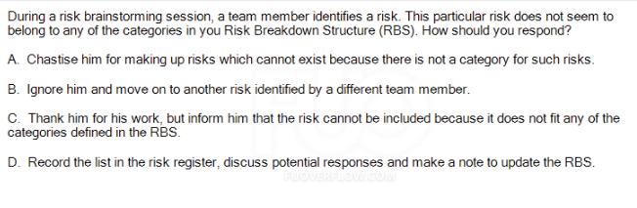

**D. Record the list in the risk register, discuss potential responses and make a note to update the RBS.**

**Explanation: It's important to remain open to all potential risks, even those that don't immediately fit into predefined categories. By recording the risk in the risk register and discussing possible responses, you acknowledge the risk and can plan accordingly. Additionally, updating the Risk Breakdown Structure (RBS) allows the project team to adapt and refine the risk management process as the project progresses.**

**Q46. Who might not be your project's stakeholders?**

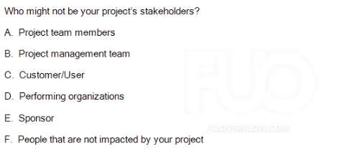

**F. People that are not impacted by your project**

**Q47. One way to classify your stakeholders is to use the Power/Interest Grid. If a stakeholder is low interest / low power, what should the Project Manager do?**

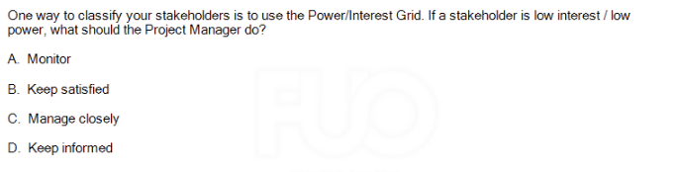

**A. Monitor**

**Q48. You just came from a meeting with one of your project stakeholders, he knew well about your project and also its potential impacts, and actively engaged in ensuring that the project is a success. How would you classify him?**

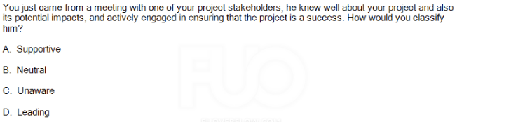

**D. Leading**

**Q49. True or False: The Project Sponsor is responsible for stakeholder expectations management.**

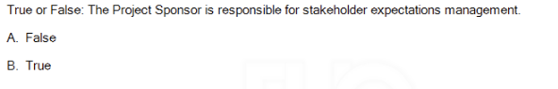

**A. False**

**Q50. You are beginning to staff your project. Which of the following will NOT be used in developing and/or communicating roles and responsibilities?**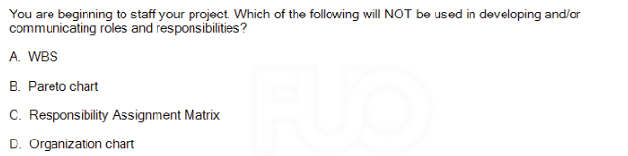

**B. Pareto chart**

Đề 3: SU24_1 (KHANG)

Q1 : All the following are characteristics of a project EXCEPT:

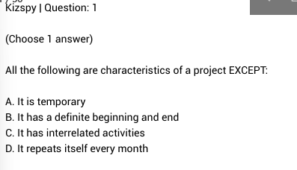



**D. It repeats itself every month**

Q2 : In a functional organization:

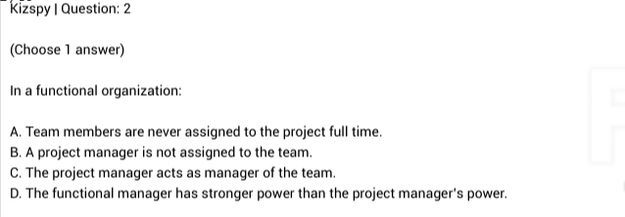

**D. The functional manager has stronger power than the project manager's power.**

Q3: You have finished planning and have begun executing the project when the client asks if you would shorten the project duration so that the project can finish 2 weeks earlier than the original plan. How are the triple constraints affected?

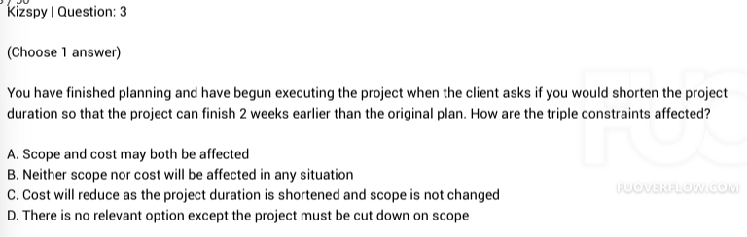

**A. Scope and cost may both be affected**

Q4 : An output of the Close Project or Close Phase process is the creation of:

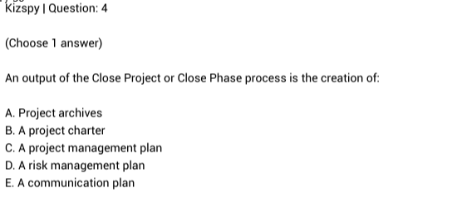

A. Project archives

**Q5 : As discussed in the Project Management course, The PMBOK® Guide knowledge area that has processes in all 5 process groups is:**

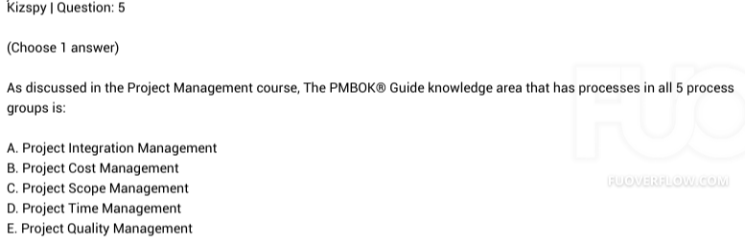

A. Project Integration Management

Q6 : Which of the following is included in a project charter?

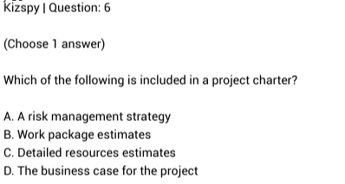

D. The business case for the project

Q7 : True or False: Scope creep represents the situation that the changes are made with the proper process and authority.

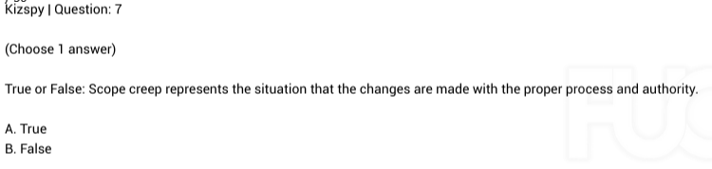

B. False

Q8 : True or False: Unregulated changes allow for innovation and flexibility. Regulating changes causes a lack of creativity.

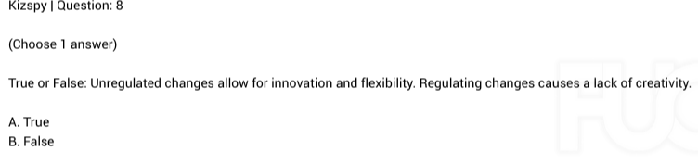

B. False

Q9 : A project manager can defend against scope creep with a good_______!

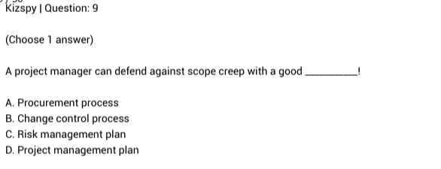

B. Change control process

Q10 : The purpose of capturing lessons learned is:

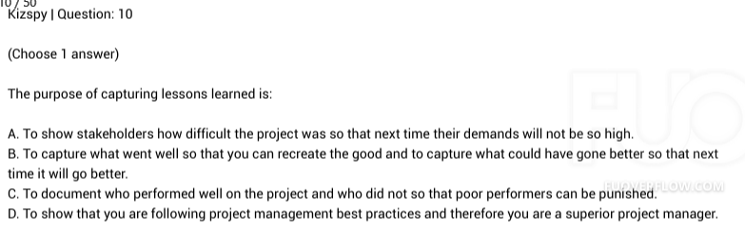

B. To capture what went well so that you can recreate the good and to capture what could have gone better so that next time it will go better.

Q11 : The Project Scope Statement should include the following:

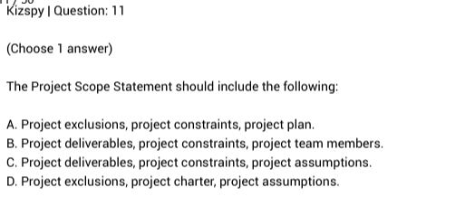

C. Project deliverables, project constraints, project assumptions.

Q12 : Which one is not the different between assumptions and constraints?

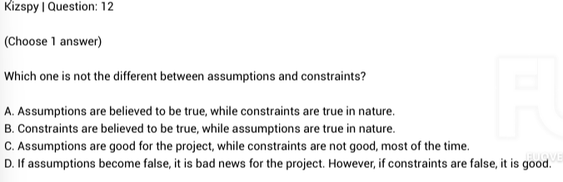

B. Constraints are believed to be true, while assumptions are true in nature.

Q13 : Which one is not the different between assumptions and constraints?

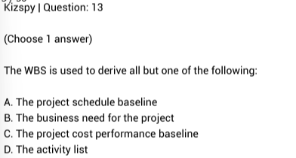

B. The business need for the project

Q14 : During project executing, a team member comes to the project manager because he is not sure what work he needs to accomplish on the project. Which of the following documents contains detailed descriptions of work packages?

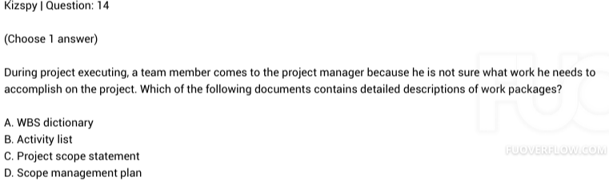

A. WBS dictionary

Q15 : All of the following are inputs to estimating activity durations except:

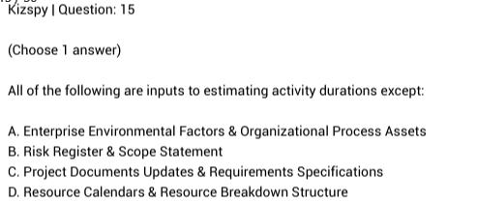

C. Project Documents Updates & Requirements Specifications

Q17 : All of the following are inputs to estimating activity durations except:



D. External

Q18 : True or False: If "develop online modules" needs to finish before "review online modules" can finish, that is called a finish to finish relationship.

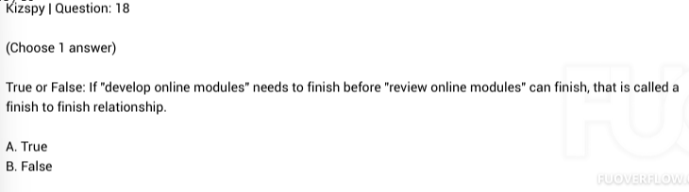

A. True

Q19 : To calculate early finish (EF) of an activity, you will

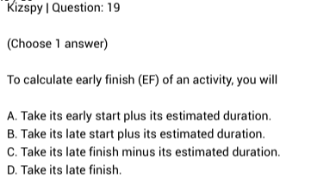

A. Take its early start plus its estimated duration.

Q20 : In a project schedule, the sequence of activities which cannot be delayed during the course of the project without extending the project end date is referred to as the:

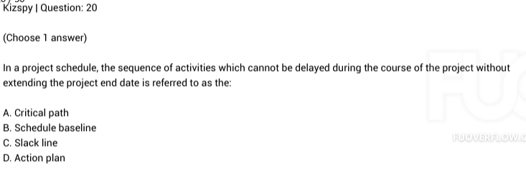



A. Critical path

Q21 : : Once the logic of a network is laid out, the project manager will conduct a forward pass and a backward pass through the network. This will provide information rrrregarding_ _and will identify the__

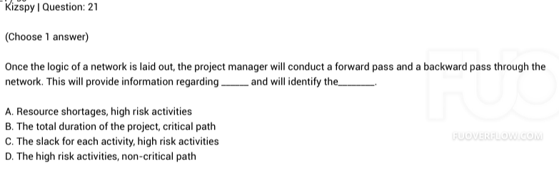

B. The total duration of the project, critical path

Q22 : Which one is NOT the approach to shorten your project schedule?

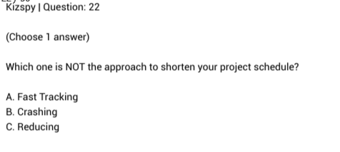

C. Reducing

Q23 : Which of the following is NOT the disadvantages of top-down estimating?

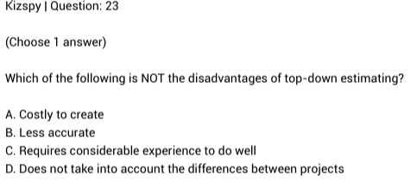

A. Costly to create

Q24 : You are building an apartment complex with four, 10,000 square foot buildings based on the same drawings you used in another city two years ago. What is the danger of estimating using the same parametric model of $50 per square foot?

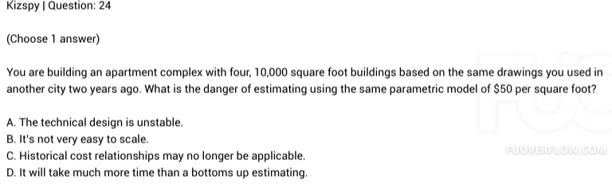

C. Historical cost relationships may no longer be applicable.

Q25 : Which of the following is NOT the disadvantage of bottom-up estimating?

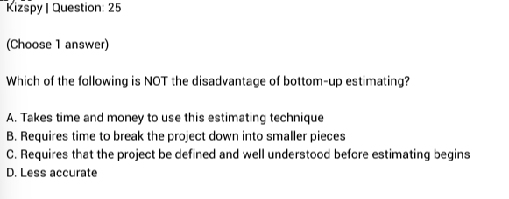

D. Less accurate

Q26 : True or False: The Cost Baseline is equal to the total of Activity Cost Estimates plus Contingency Reserves.

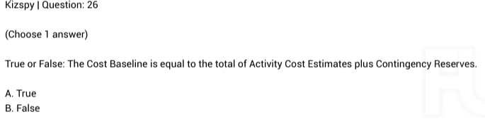

A. True

Q27 : Earned value management integrates scope, cost, and schedule measures to:

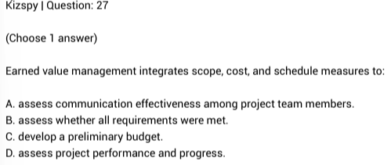

D. assess project performance and progress.

Q28 : The discipline of quality management complements the discipline of project management. Both recognize the importance of:

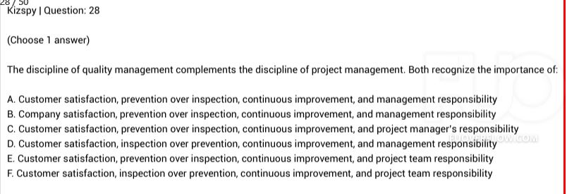

A. Customer satisfaction, prevention over inspection, continuous improvement, and management responsibility

Q29 : True or False: Project quality focuses on the project management processes used to meet project objectives.

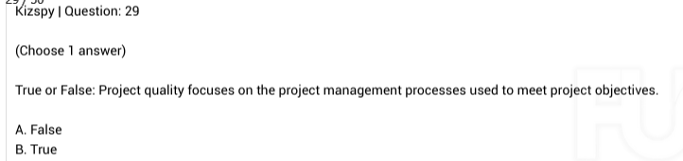

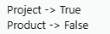

B. True

Q30 : True or False: The Process Improvement Plan is a component of the project management plan that details how project management and development processes are to be analyzed in order to identify how to increase their value.

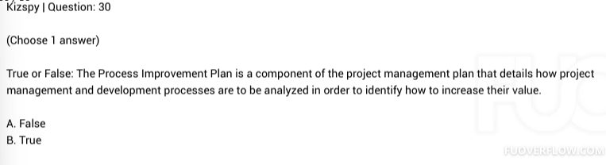

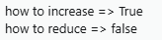

B. True

Q31 : True or False: Performing quality assurance within the context of a project involves taking actions to eliminate causes of unsatisfactory project performance.

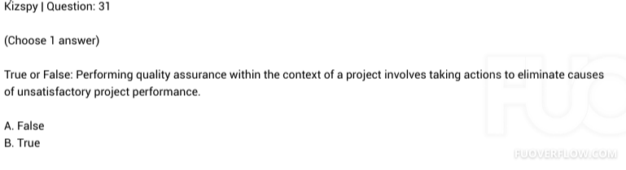

B. True

Q32 : True or False: Performing quality control within the context of a project involves taking actions to eliminate causes of unsatisfactory project performance.

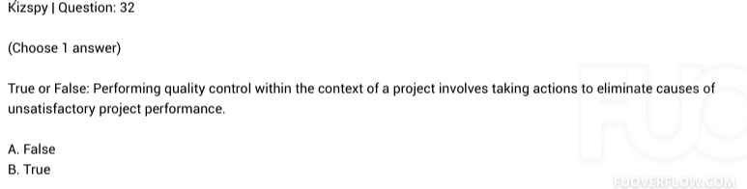

B. True

Q33 : True or False: Project Human Resource Management includes the processes that define the tasks and assign them to suitable resources, and motivate project team to complete the tasks.

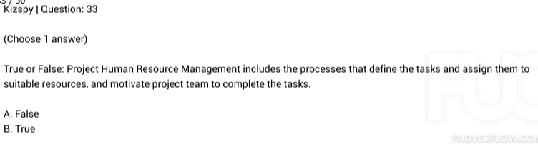

B. True

Q34 : True or False: Conflict management is the process by which the project manager uses appropriate managerial techniques to deal with the inevitable disagreements that develop among those working toward project accomplishment.

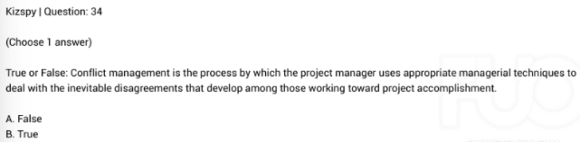

B. True

Q35 : Two team members disagree on how to solve a project issue. They express their disagreement and then engage in a professional debate. This is an example of:

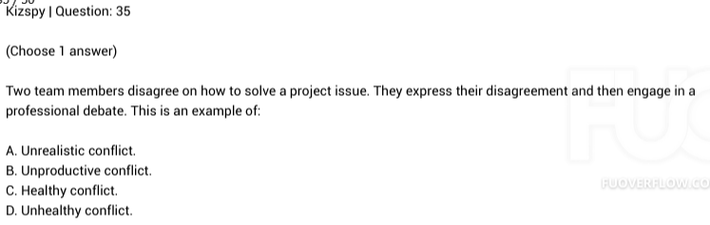

C. Healthy conflict.

Q36 : Which one of these is not the approaches to conflict discussed in the Project Human Resources Management Lesson?

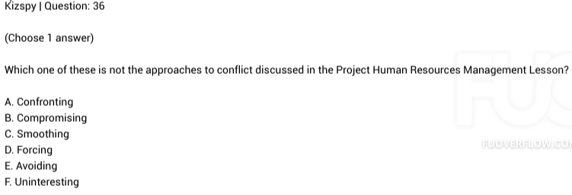

F. Uninteresting

Q37 : What does RAM stand for:

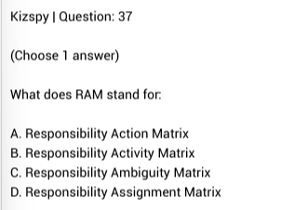

D. Responsibility Assignment Matrix

Q38 : :

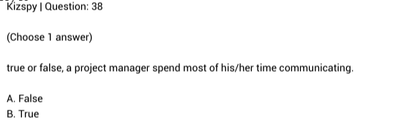

B. True

Q39 : You are beginning to staff your project. Which of the following will NOT be used in developing and/or communicating roles and responsibilities?

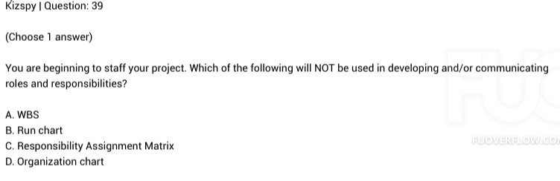

B. Run chart

Q40 : Lateral communication is communication to/from:

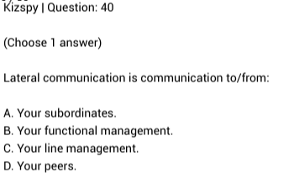

D. Your peers.

Q41 : Who should take the most responsibility for clear and effective communication?

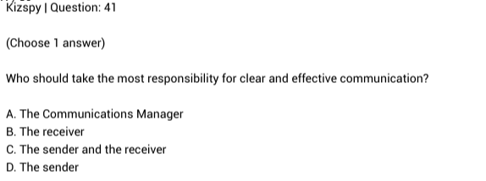

C. The sender and the receiver

Q42 : During status review meetings to evaluate project performance and progress, which tool or technique is NOT preferred to use?

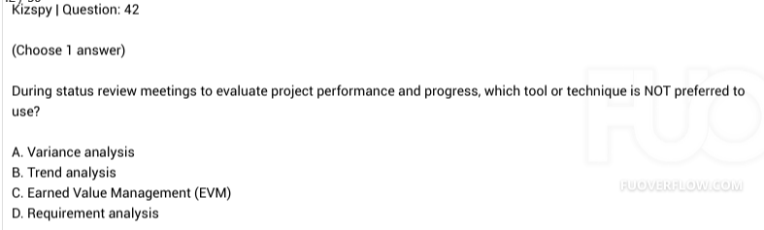

D. Requirement analysis

Q43 : True or False: A positive risk is an opportunity; a negative risk is a threat.

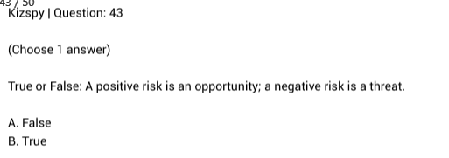

B. True

Q44 : Which element should NOT be included in risk management plan?

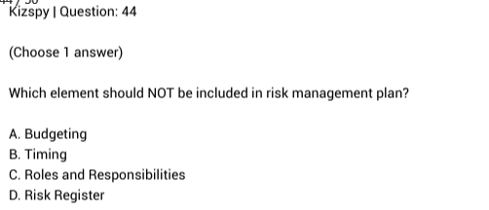

D. Risk Register

Q45 : If the response you choose is to transfer a risk this means that:

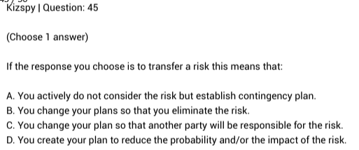

C. You change your plan so that another party will be responsible for the risk.

Q46 : True or False: When you choose to transfer your project risk to a third party, it will definitely rise to secondary risk.

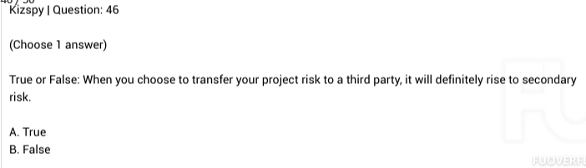

**B.False**

Q47 : Who is the stakeholder that will ultimately use the product or service you are creating?

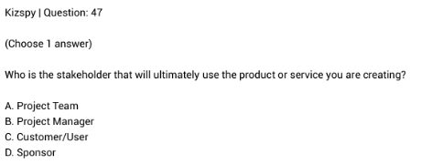

C. Customer/User

Q48 : One way to classify your stakeholders is to use the Power/Interest Grid. If a stakeholder is low interest / high power,what should the Project Manager do?

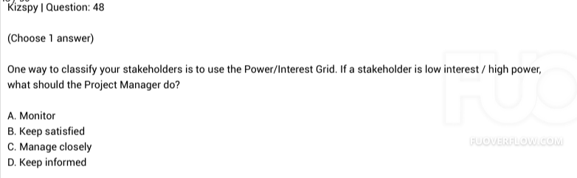

B. Keep satisfied

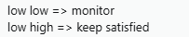

Q49 : You just came from a meeting with one of your project stakeholders, he knew about your project and also its potential impacts, and he always supported for the work and its outcomes. How would you classify him?

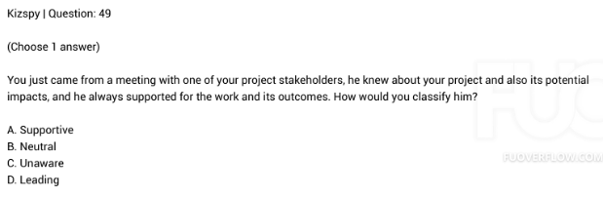

A. Supportive

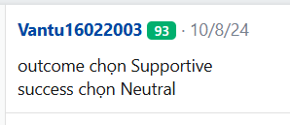

Q50 : True or False: The Project Manager is responsible for stakeholder expectations management.

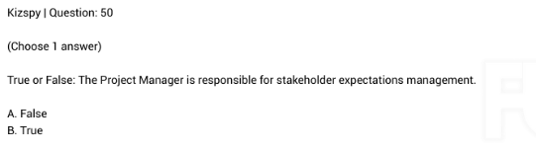

B. True

Đề 4: SU23_(Trường)

**(Choose1 answer)**

**Project scope differs from product scope in that:**

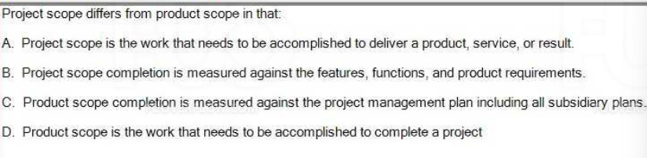

A. Project scope is the work that needs to be accomplished to deliver a product, service, or result.

**(Choose1 answer)**

**The five project management process groups as described in the PMBOK® Guide and discussed in the preceding lesson are:**

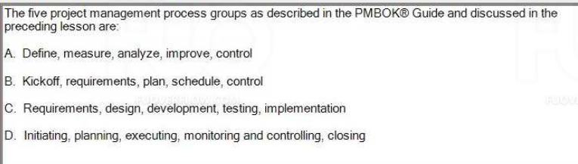

D. Initiating, planning, executing, monitoring and controlling, closing

**Q5 (Choose1 answer)**

**You are assigned as the project manager in the middle of the project. The project is within the baselines, but the customer is not happy with the performance of the project. What is the first thing you should do?**

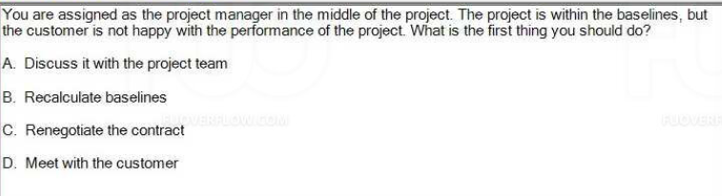

D. Meet with the customer

**Q6 - (Choose**

**1 answer)**

**A significant event in a project that may indicate completion of a major phase is a/an:**

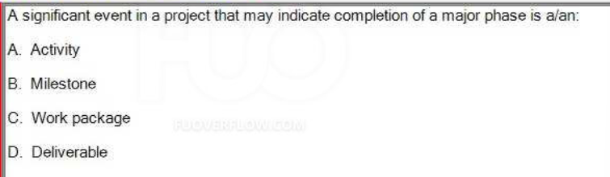

B. Milestone

**Q7 - (Choose1 answer)**

**We discussed three types of matrix organizations, they are:**

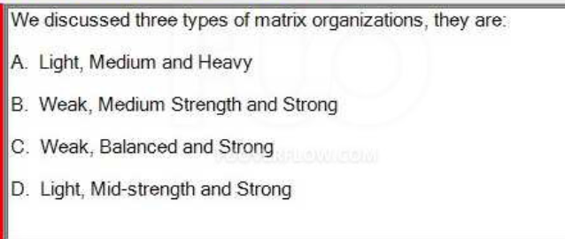

C. Weak, Balanced and Strong

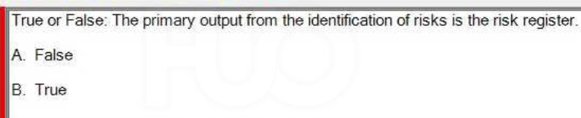

B. True

**Q13- (Choose1 answer)**

**In a project context, risk is defined as:**

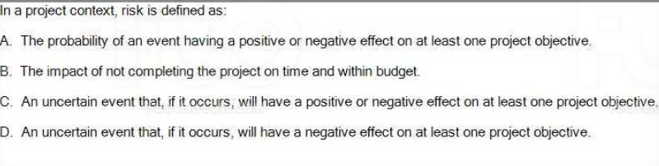

C. An uncertain event that, if it occurs, will have a positive or negative effect on at least one project objective.TÍ TÔI SỬA LẠI ĐỎ SAU CHOOOOOO LÀM XONG ĐÃ :>

**Q18- Which one of these most correctly defines contingency reserve?**

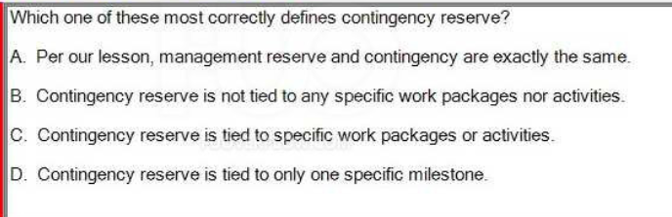

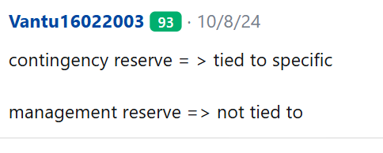

C. Contingency reserve is tied to specific work packages or activities.

**20 - In Earned Value Management Technique, you can compute the Cost Performance Index (CPI) by applying which of following formula?**

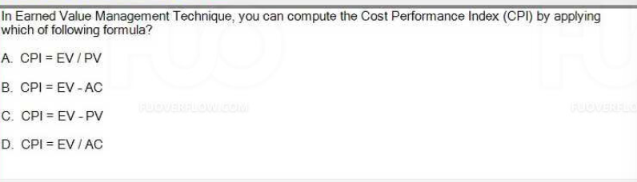

D. CPI EV/AC

**Q24 - When you report project status you compare actual performance to:**

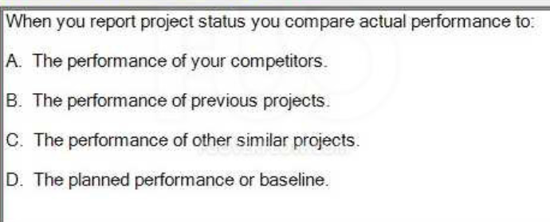

D. The planned performance or baseline.

**Q25- Which process groups must be included in every project?**

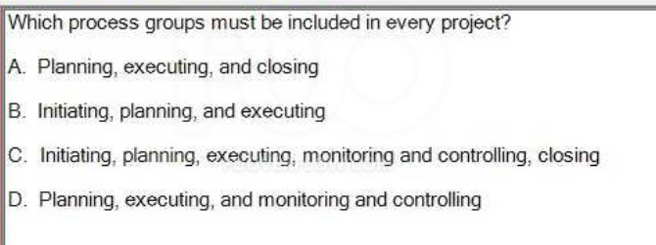

C. Initiating, planning, executing, monitoring and controlling, closing.

**Q28- True or False: Performing quality control within the context of a project involves applying the planned,systematic quality activities to ensure that the project correctly employs all processes needed to meet project objectives and product requirements.**

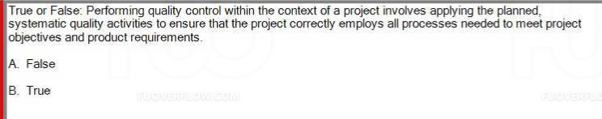

B. True

**Q30- True or False: It should not to add extra cost to the estimates when you are concerned that your estimates might not be correct, especially if you think they are too low.**

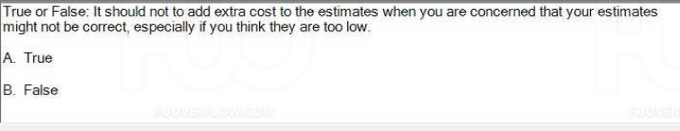

B. TRUE

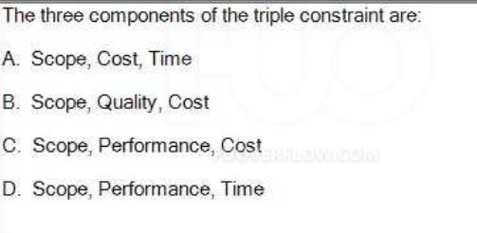

A. Scope, Cost, Time

**Q33- Your Schedule Performance Index (SPI) is lesser than 1 means you are:**

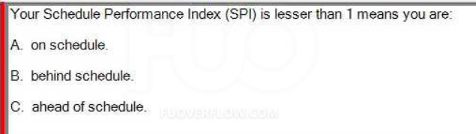

B. behind schedule

**Q34 - True or False: If you are not certain who your stakeholders are, asking who will use the product or service being created can be helpful.**

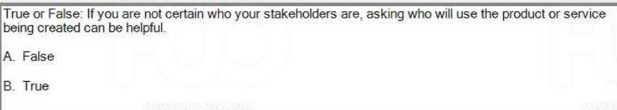

B. True

**37- (Choose1 answer)**

**A Communications Management Plan does the following:**

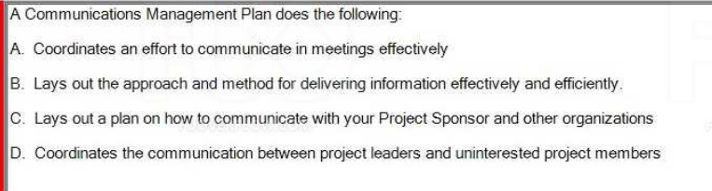

B. Lays out the approach and method for delivering information effectively and efficiently.

**Q38 :Choose1 answer)**

**Duration (Days)**

**Task Name**

**Start Date**

**End Date**

**Planned Value**

**Percent Complete**

**Actual Cost**

**A project manager**

**Define**

**8/1**

**8/31**

**30**

**$ 1,000.00**

**$ 1,200.00**

**100%**

**IS**

**currently managing**

**Measure**

**9/1**

**9/30**

**29**

**$ 3,000.00**

**$ 2,900.00**

**100%**

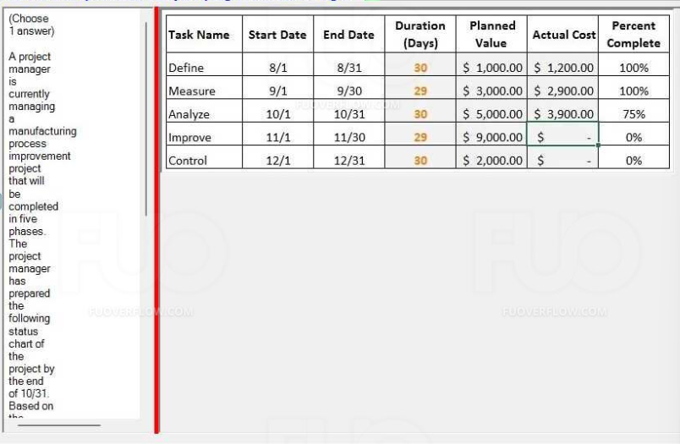ĐÁP ÁN : 8000

**(Choose1 answer)**

**A useful tool in identifying risks is the SWOT analysis. What does SWOT stand for?**

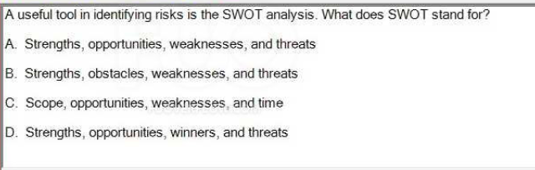

A. Strengths, opportunities, weaknesses, and threats

**Q43- The work breakdown structure can best be thought of as an effective aid for communications.**

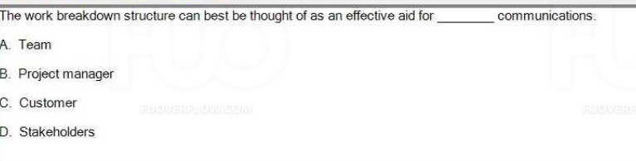

D. Stakeholders

**Q44- When you use the RACI or Responsible, Accountable, Consult, Inform version of the RAM, those responsible persons are:**

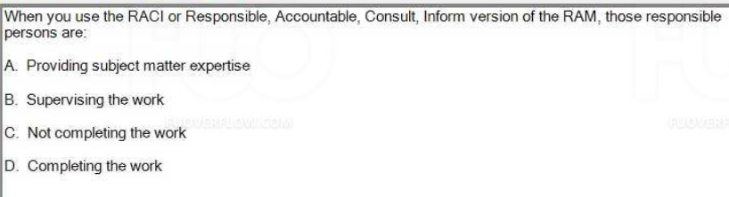

D. Completing the work

**hose consulted persons are= > A. Providing subject matter expertise**

**Q47- Given 14.000 USD is the most likely of the estimated cost of the activity, 8.000USD is the optimistic value and 26.000USD is the pessimistic one. By using the PERT (Program Evaluation and Review Technique) analysis to calculate the expected activity cost, which of the following is the result?**

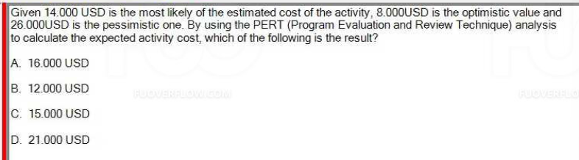

C. 15.000USD ((8+4*14+26)/6=15)

Đề 5:FA23(Hải)

**Q1Which of the following is NOT the output of Plan Scope Management process? (Choose 2 answers)**

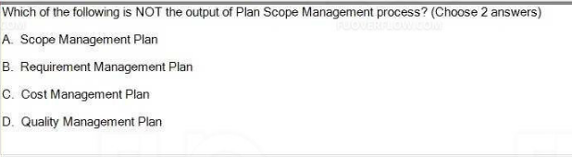

**C. Cost Management Plan**

**D. Quality Management Plan**

**Q3 Which of the following is the most correct statement regarding management and contingency reserves?**

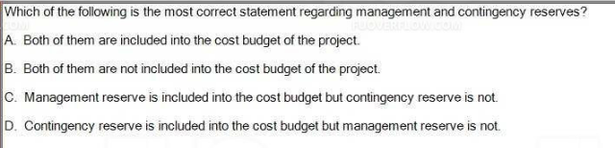

**D. Contingency reserve is included into the cost budget but management reserve is not.**

**Q4. True or False: Influence means you have the right to apply resources, make decisions and give approvals.**

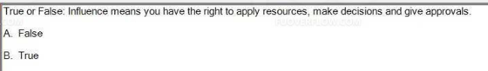

**A. False**

**Q5. True or False: Your role as the project manager during quality control is to implement the quality management plan using the appropriate tools and techniques, in order to ensure that work is being performed according to required quality standards**

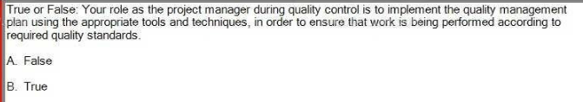

**B. True**

**Q6. (Choose 1 answer)**

**Once you and your team identify and assess risks and develop responses you:**

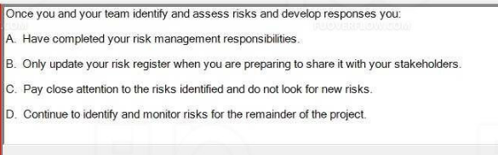

**D. Continue to identify and monitor risks for the remainder of the project.**

**Q7. True or False: Project quality focuses on the project management processes used to meet project objectives.**

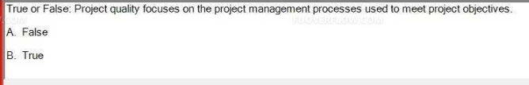

**B. True**

**Q8. As part of planning you have created a scope baseline, a budget baseline, and a schedule baseline. Should those baselines ever be allowed to change?**

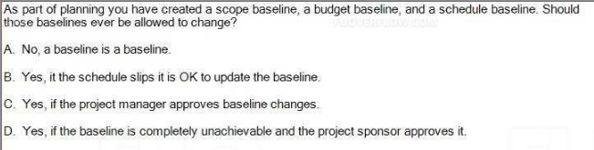

**D. Yes, if the baseline is completely unachievable and the project sponsor approves it.**

**Q9.**

**(Choose 1 answer)**

**A project manager is trying to complete a software development project, but cannot get enough attention for the project. Resources are focused on completing process-related work, and the project manager has little authority to assign resources. What form of organization must the project manager be working in?**

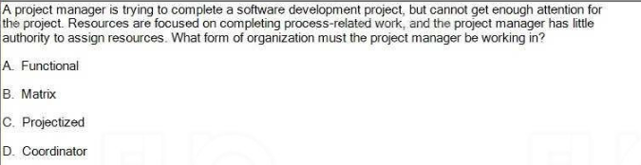

**A. Functional**

**Q10. All the following occur during the planning process group EXCEPT:**

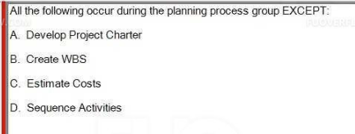

**A. Develop Project Charter**

**Q11. Which of the following is a characteristic of project management process**

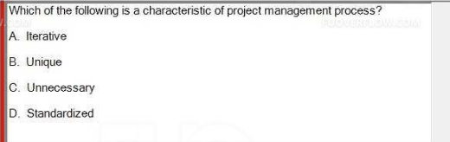

**A. Iterative**

**Q12. True or false, a project manager spend most of his/her time communicating**

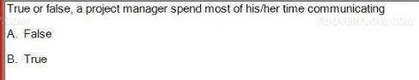

**B. True**

**Q13. True or False: Using bottom-up estimating techniques when activity durations or resource quantities are uncertain.**

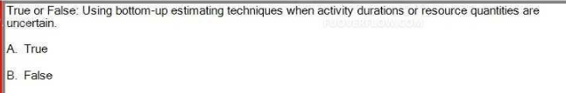

**B. False**

**Q14. What is a program?**

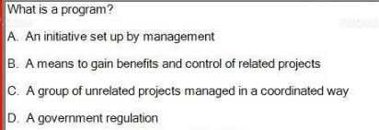

**B. A means to gain benefits and control of related projects**

**Q15. True or False: Performance reporting aims to inform stakeholders how resources are being used to achieve the project's objectives.**

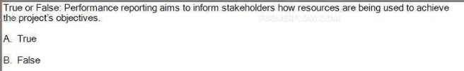

**A. True**

**Q16. True or False: The sender is responsible to make the information clear, complete, and appropriate to the needs of the receiver. The receiver is responsible to provide feedback to acknowledge that the message has been received and understood.**

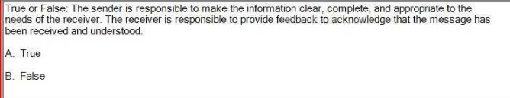

**A. True**

**Q17. True or False: If "develop online modules" needs to begin before "review online modules" can begin, that is called a start to start relationship.**

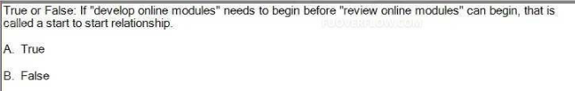

**A. True**

**Q18. True or False: You should use parametric estimating when your historical information used to develop the model was qualitative and not readily quantifiable.**

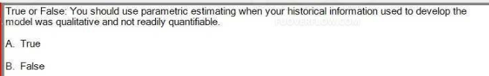

**B. False**

**Q19. As you plan your project, you do so thinking that all team members will be assigned to your project for at least 50% of their available time. This is an example of**

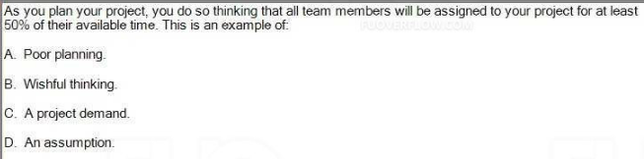

**D. An assumption.**

**Q21. Which one of below situations is not correct when discussing about Responsibility Assignment Matrix**

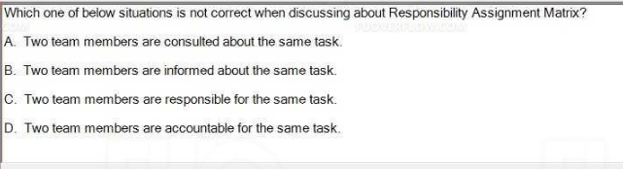

**D. Two team members are accountable for the same task.**

**Q22. The network diagram can be used to**

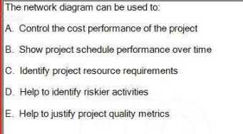

**B. Show project schedule performance over time**

**Q24. One way to classify your stakeholders is to use the Power/Interest Grid. If a stakeholder is high interest / high power, what should the Project Manager do?**

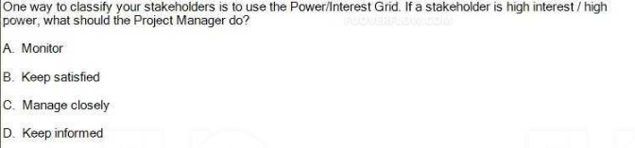

**C. Manage closely**

**High power- high interest: closely manage their expectations.**

**High power- low interest: keep satisfied**

**Low power - high interest: keep informed**

**Low power - low interest: monitor these people, but do not bore them with excessive communication**

**Q25. The discipline of quality management complements the discipline of project management. Both recognize all but one of the following**

**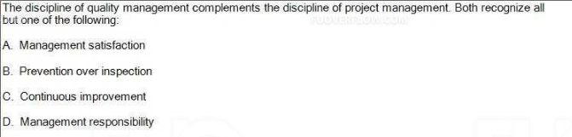  
A. Management satisfaction**

**Q26. Which of the items below do you think belong in the cost management plan?**

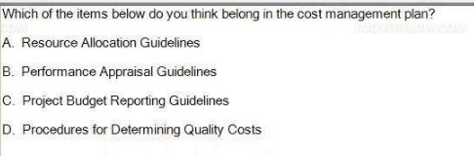

**C. Project Budget Reporting Guidelines**

**Q27.**

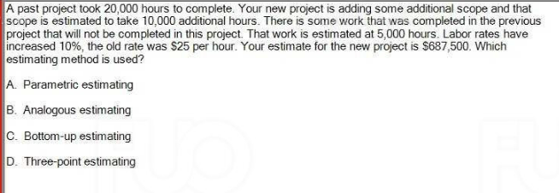

**C. Bottom-up estimating**

**Q28. A project management plan should be realistic in order to be used to manage the project. Which of the following is the best method to achieve a realistic project management plan?**

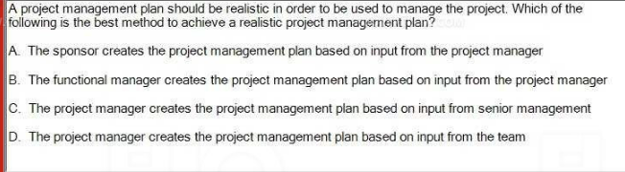

**D. The project manager creates the project management plan based on input from the team**

**Q29. The Project Scope Statement should include the following:**

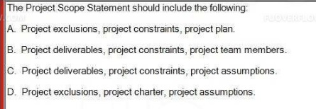

**C. Project deliverables, project constraints, project assumptions.**

**Q30. True or False: A Work Breakdown Structure (WBS) is a deliverable-oriented hierarchical decomposition of the work to be executed by the project team.**

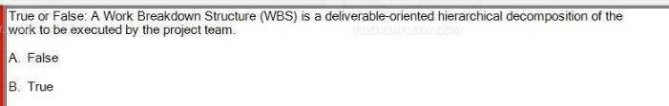

**project team -> true**

**project manager -> false**

**B. True**

**Q31. You just came from a meeting with one of your project stakeholders, he knew about your project and was not against it, but did not seem to be particularly interested in it either. How would you classify him?**

**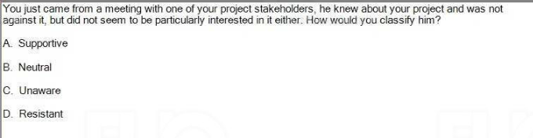  
B. Neutral**

**Q32. Which of the following is included in a project charter?**

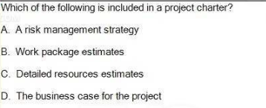

**D. The business case for the project**

**Q33. True or False: Project Human Resource Management includes the processes that organize, manage, and lead the project team.**

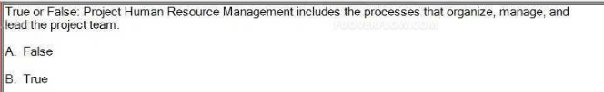

**B. True**

**Q34. A company is making an effort to improve its project performance and create historical records of past projects. What is the best way to accomplish this?**

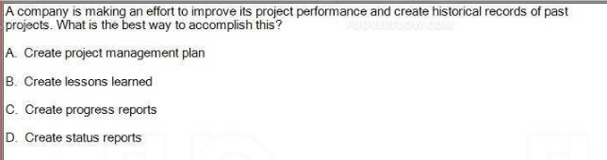

**B. Create lessons learned**

**Q35. All of the following are parts of the scope baseline EXCEPT the:**

**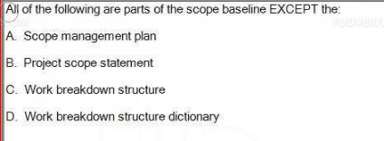  
A. Scope management plan**

**Q36. The 8-80 rule refers to:**

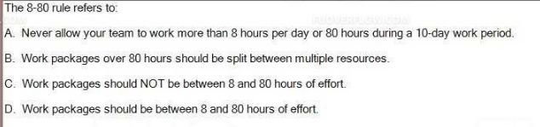

**D. Work packages should be between 8 and 80 hours of effort.**

**Q37. The Risk Management Plan is a subsidiary to the ____________ document**

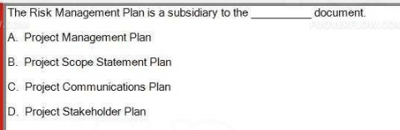

**A. Project Management Plan**

**Q39. True or False: When you are concerned that your estimates might not be correct, especially if you think they are too low, you should pad the estimate and add extra.**

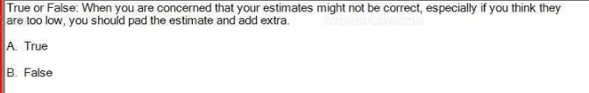

**B. False**

**Q41. Lateral communication is communication to/from:**

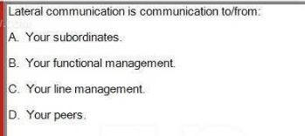

**D. Your peers.**

**Q42. You and another project manager disagree over whether a team member should work on your team or on her team. You decide that the team member can work for the other project manager in the afternoon and the other project manager says it is OK for the team member to work for you in the morning. The truth is you both wanted this person fulltime. The conflict resolution approach you have both used is:**

**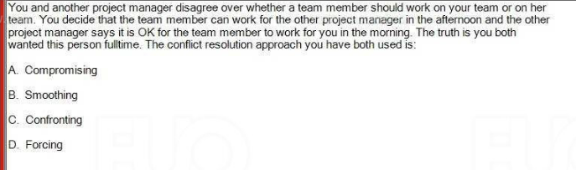  
A. Compromising**

**Q43. All of the following are inputs to estimating activity durations except:**

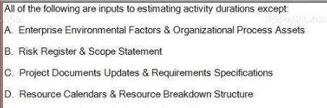

**C. Project Documents Updates & Requirements Specifications**

**Q44.True or False: Conflict management is the process by which the project manager uses appropriate managerial techniques to deal with the inevitable disagreements that develop among those working toward project accomplishment.**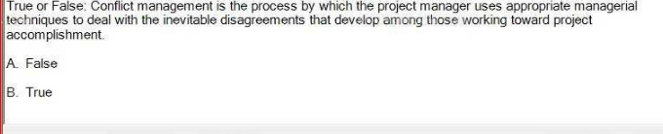

**B. True**

**Q45. True or False: The Process Improvement Plan is a component of the project management plan that details how project management and development processes are to be analyzed in order to identify how to reduce their value.**

**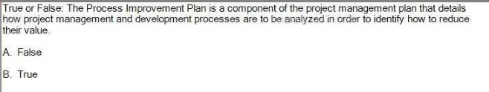  
A. False**

**reduce their value = F**

**incre thẻir value = T**

**Q46. Some of the major sources of conflict that a project manager may influence are:**

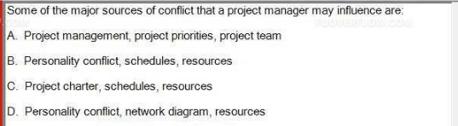

**D. Personality conflict, network diagram, resources**

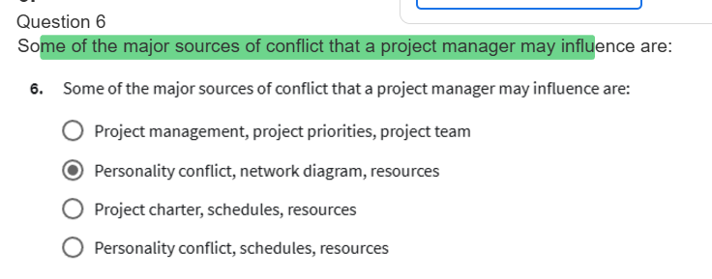

**Q47. In our lessons the acronym RAM stands for:**

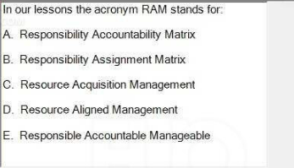

**B. Responsibility Assignment Matrix**

**Q48. The primary role of the project manager is:**

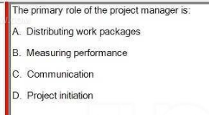

**C. Communication**

**Q49. Which of the following is NOT true regarding milestones?**

**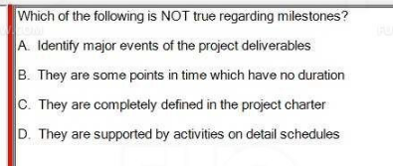  
C. They are completely defined in the project charter**

**Q50. Your Cost Performance Index (CPI) is greater than 1 means you are:**

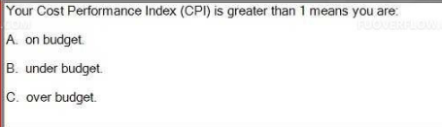

**B. under budget.**

Đề 6: [RE_FA23](https://fuoverflow.com/threads/pmg201c_re_fa23_684554.1235/) (Phát)

Q1 : True or False: Project scope statement is better to define inclusions (in-scope items) than identify only exclusions (out of scope items).  
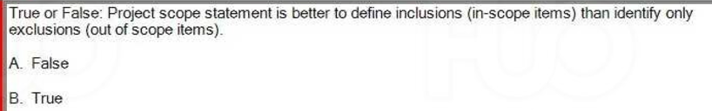  
B. True  
  
Q2 : True or False: Your project might pay more in order to reduce the schedule when using Crashing approach, but that is not often true if using Fast Tracking approach.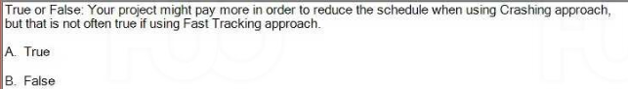  
A. True

Q5. True or False: A Project is defined as being unique and temporary, with an undefined start and finish.  
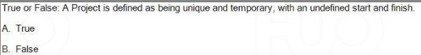  
B. False

Q17. What are the 5 approaches to conflict discussed in the Project Human Resources Management Lesson?

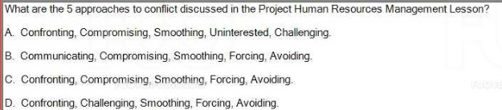  
**C. Confronting, Compromising, Smoothing, Forcing, Avoiding.**

Q20. The project sponsor has just signed the project charter. What is the next thing to do?

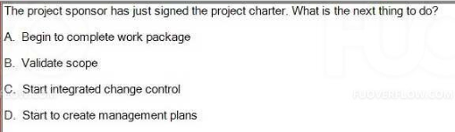  
**D. Start to create management plans**

Q23. You have a project to build a new fence. The fence will form a square. Each side is to take one day to build, and $1,000 has been budgeted per side. The sides are planned to be completed one after the other. Today is the end of Day 3. Using the following project status chart to calculate the current BAC.  
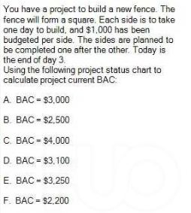  
**C. BAC = $4.000**

Q26. True or False: Product quality focuses on the goods and services. **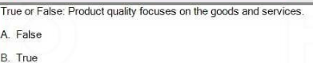  
B. True**

Product => True  
Project =>False

Q30. The three components of the triple constraint are:

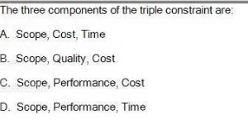

**A. Scope, Cost, Time**

Q37. True or False: The Project Budget is equal to the Cost Baseline budget plus Management Reserve.  
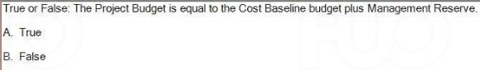 **A. True**

Q41. True or False: The Forward Pass is used through the activities to determine the critical path & available float of the project.  
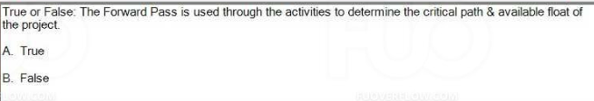  
**A. True**

Q42. Which of the components below do you think NOT belong in the cost management plan?

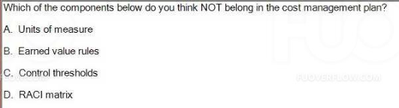  
**D. RACI matrix**

Q44. True or False: Using bottom-up estimating techniques when the detail is available and the accuracy is needed.  
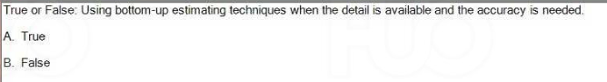  
**A. True**

Q48. Which one is the correct matching of report types and the descriptions?

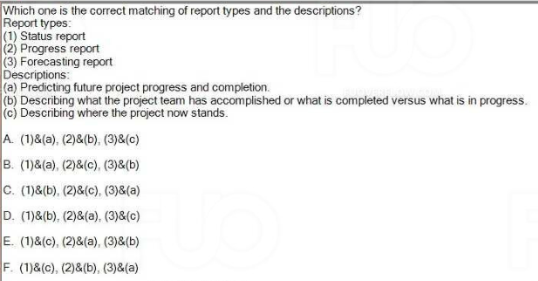

**F. (1)&(c), (2)&(b), (3)&(a)**

Q49. True or False: When it comes to projects, the emphasis is on strategic quality management. Quality is not an accident, quality is part of the plan, and quality is everyone's job.  
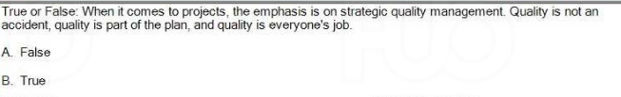  
**B. True**

Đề 7: SP24 (Khang)

**Q1 : (Choose 1 answer)**

**A project is plagued by requested changes to the project charter. Who has the primary responsibility to decide if these changes are necessary**

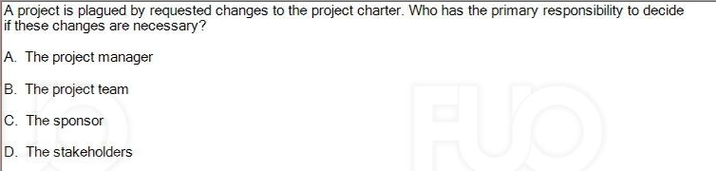

**C. The sponsor**

**Q10-True or False: The Backward Pass is used through the activities to determine the total duration of the project.**

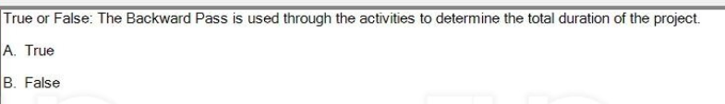

B. False

**Q12-Which organization structure can provide the most power for the project manager?**

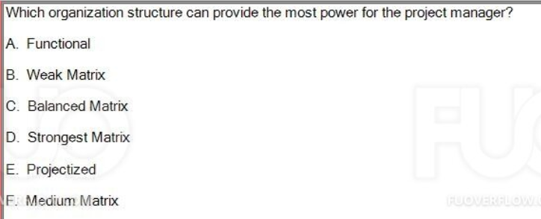

E. Projectized

**Q14-True or False: Each group of persons involved in the project should be assigned, and always needs to know their role and responsibility.**

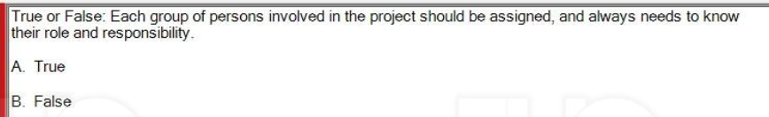

A True

**Q15- Which one is not the causes of scope creep?**

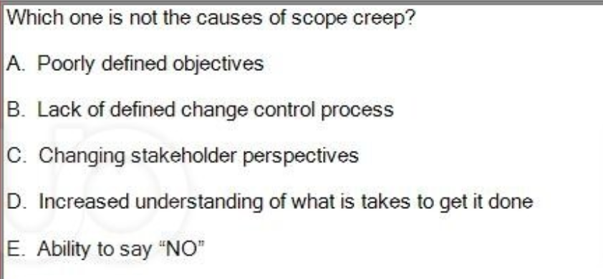

D. Increased understanding of what is takes to get it done

**Q17-Lateral communication is NOT communication to/from:**

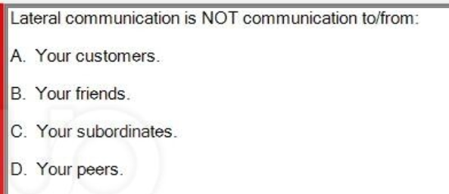

C. Your subordinates.

CÓ CHỮ “NOT” =>C

KO CÓ “NOT” => D

**Q20 -Your project had a team of which consists of yourself, a tester, five developers and a communicator. As the project is behind schedule so one more developer has been assigned to your team. How many communication channels on your team now?**

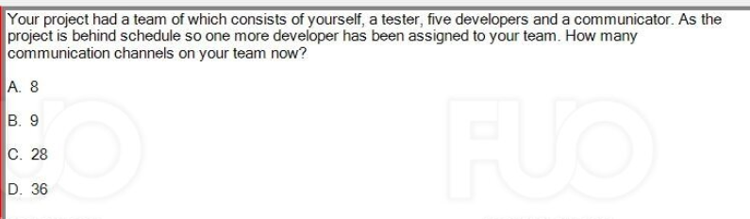

D. 36

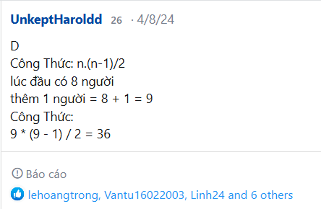

**Q22- True or False: The danger of estimating using the same parametric model is the no longer applicable of historical data.**

I

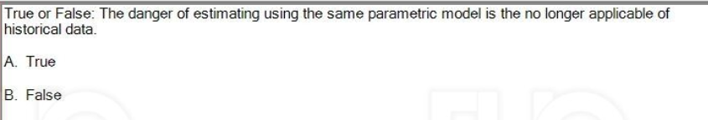

A. True

================================================

**Q30-Which item would most likely NOT be part of a basic communication plan:**

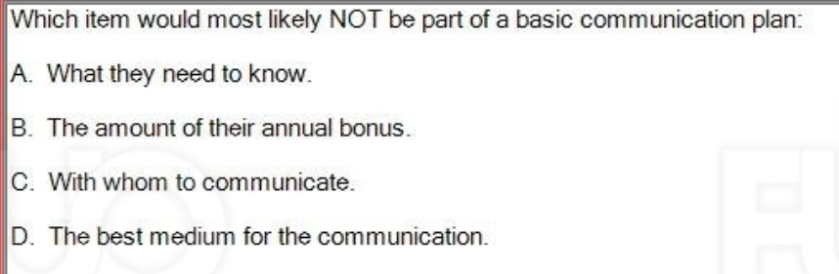

B. The amount of their annual bonus. (CÓ TRONG COURSERA)

**Q31-To calculate late start (LS) of an activity, you will**

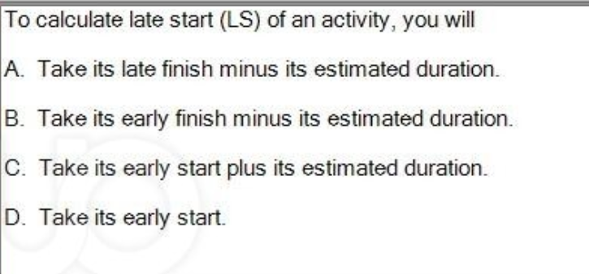

A. Take its late finish minus its estimated duration.

**Q34- You are scheduling an activity which involves a government agency. What type of dependency are you working on?**

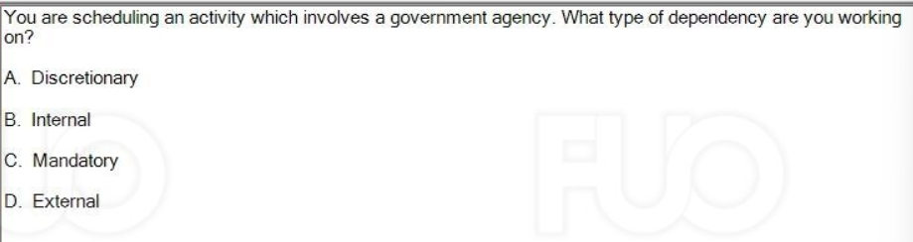

C. Mandatory (CẦN TRA LẠI CHỌN C VÀ D RẤT NHIỀU )

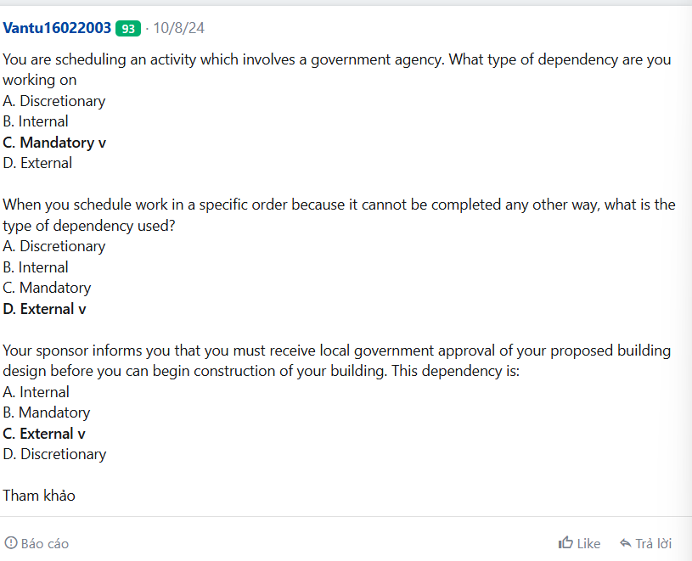

**Q35- You have a project to build a new fence. The fence will form a square.Each side is to take one day to build, and $1,000 has been budgeted per side. The sides are planned to be completed one after the other.Today is the end of day 3.**

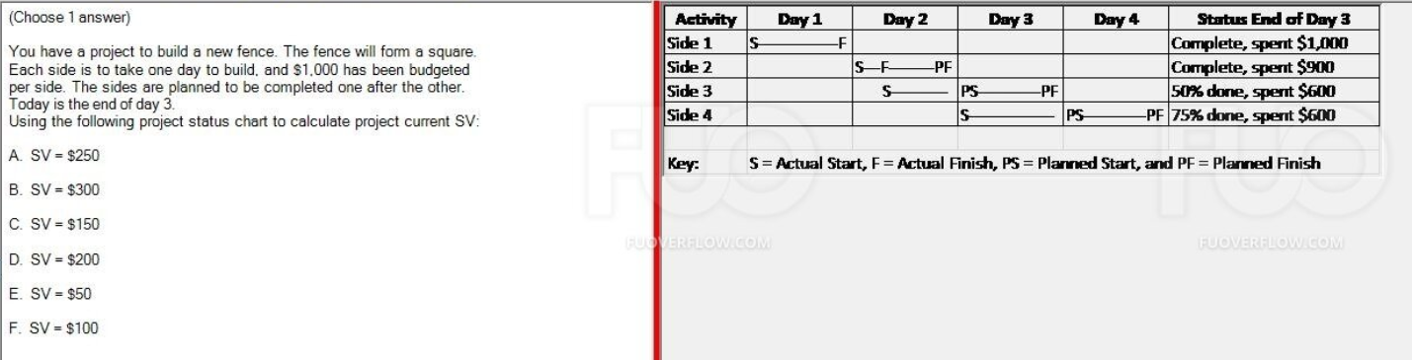

B. SV = $250

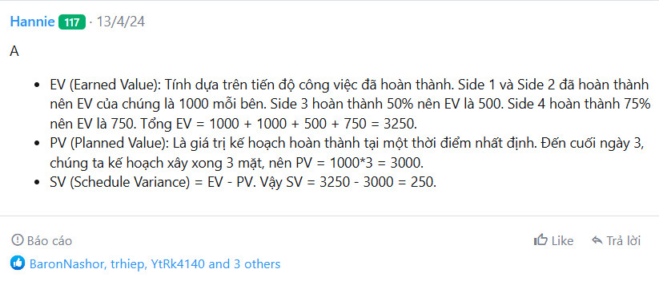

**Q38- Your stakeholder register is your primary output and should at least contain:**

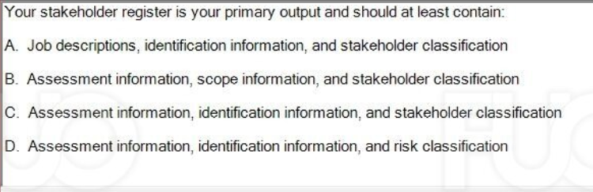

C. Assessment information, identification information, and stakeholder classification

**Q40-If "review online modules" needs to begin before "develop online modules" can finish, that is called a:**

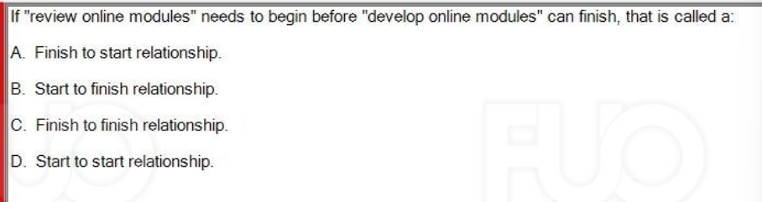

B. Start to finish relationship.

**Q42- To manage a project effectively, work should be broken down into small pieces. Which of the following does not describe how far to decompose the work?**

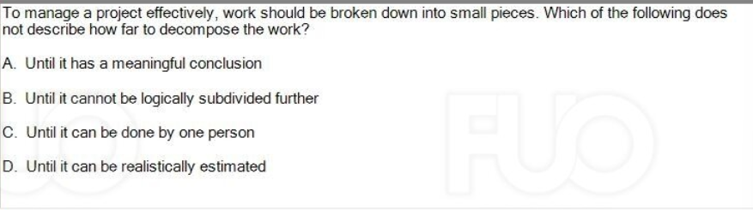

C. Until it can be done by one person

**Q43-What description defines Bottoms Up Estimating?**

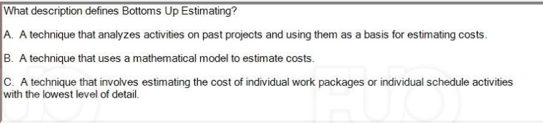

C. A technique that involves estimating the cost of individual work packages or individual schedule activities with the lowest level of detail.

**Q44-Which of the following action should not include in the Scope Management Plan?**

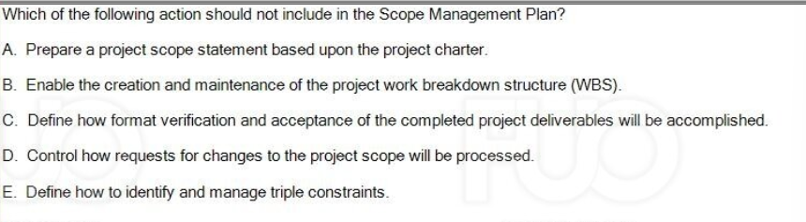

E. Define how to identify and manage triple constraints.

**Q45-The definition of a stakeholder includes:**

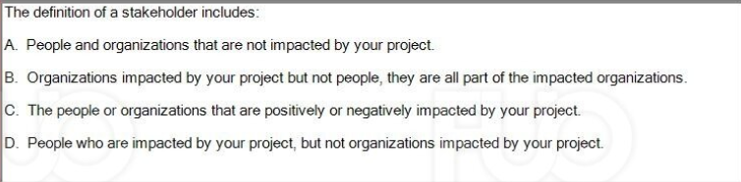

C. The people or organizations that are positively or negatively impacted by your project.

**Q50- An estimate created by looking at a similar project or activity and then adding or subtracting to or from the estimate based on the differences between the two is called:**

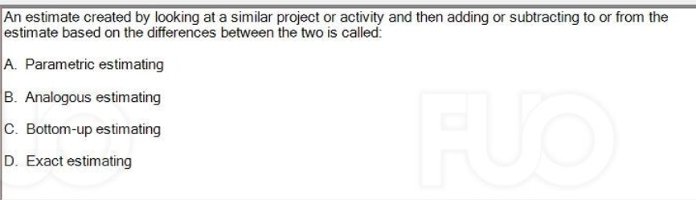

B. Analogous estimating

Đề 8:RE_SP24(Hải)



**Q1 True or False: If you want to identify who your stakeholders are, asking who will not be impacted by the product or service being created can be helpful.**

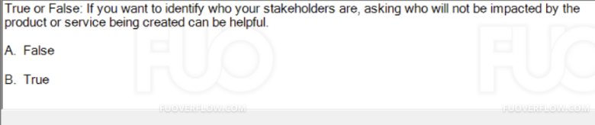

**A.False**

**Q3 Which of the following is NOT likely to be documented in a communications management plan?  
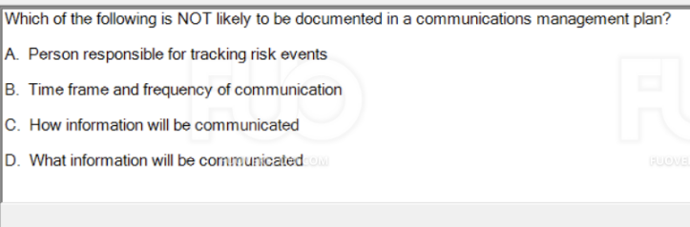**

**A. Person responsible for tracking risk events**

**Q4 The best time to assign a project manager to a project is during:**

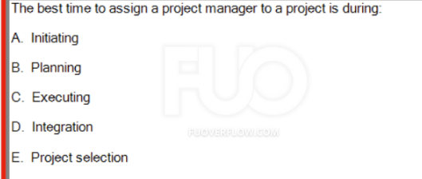

**A. Initiating**

**Q5 Which one is correct view of conflict?**

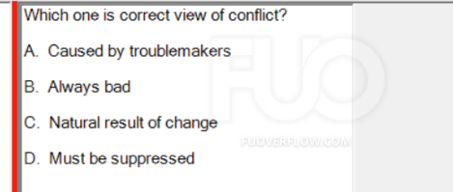

**C. Natural result of change**

**Q6 The WBS is used to derive all but one of the following:**

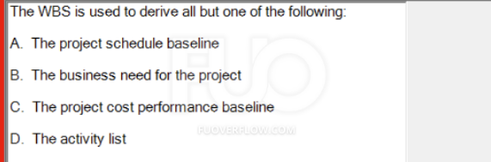

**B. The business need for the project**

**Q7 The network diagram is the best tool for demonstrating:**

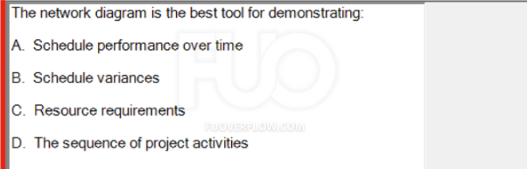

**D. The sequence of project activities**

**Q8 Which statement is not correct?**

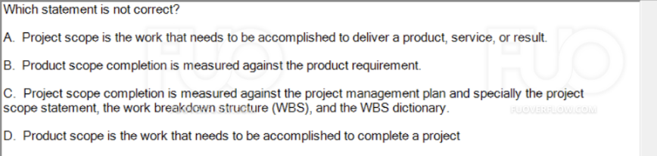

**D. Product scope is the work that needs to be accomplished to complete a project**

**Q9 When you schedule work in a specific order because it cannot be completed any other way, what is the type of dependency used?**

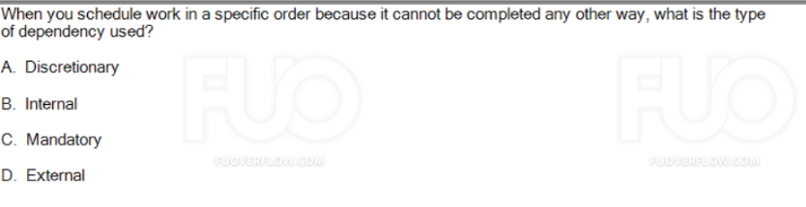

**C. Mandatory**

**Q11 All of the following is responsible for documenting lessons learned, except:**

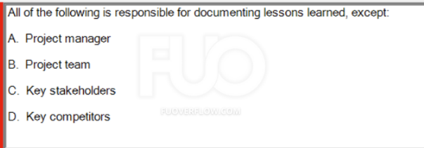

**D. Key competitors**

**Q13 True or False: The primary goal of project risk management is to maximize the likelihood and impact of negative events or threats and to minimize the likelihood and impact of positive events or opportunities  
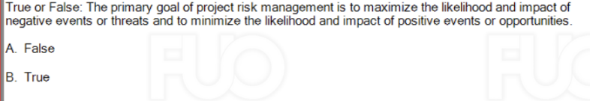**

**A. False**

**Q14 Project Human Resource Management includes the processes that define the tasks and assign them to suitable resources, and motivate project team to complete the tasks**

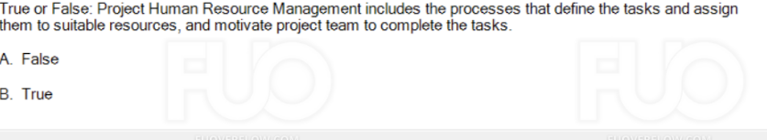

**B. True**

**Q15 Which one is not the five engagement levels of stakeholders?**

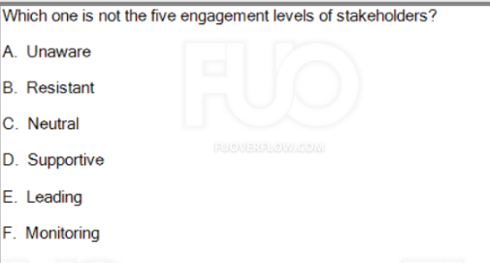

**F. Monitoring**

**Q16 In Earned Value Management Technique, you can compute the Estimate At Completion (EAC) by applying which of following formula? (Notes: BAC: Budget At Completion)  
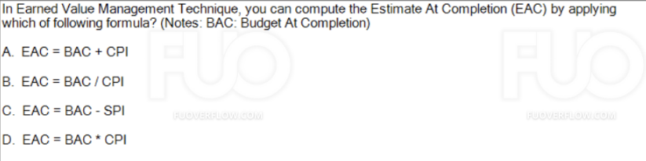**

**B. EAC= BAC/CPI**

**Q17 When you and your team know that a positive risk has a high likelihood of occurring and it will be very beneficial if it does:  
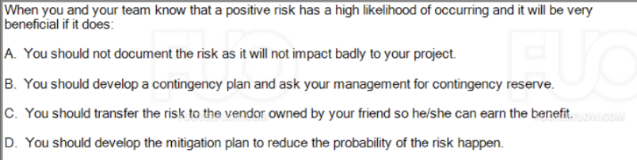  
B. You should develop a contingency plan and ask your management for contingency reserve**

**Q19 True or False: Risk management is one-time process. You need to plan for all possible risks at the project beginning and then follow defined actions to control those risks until they are closed or cancelled.  
  
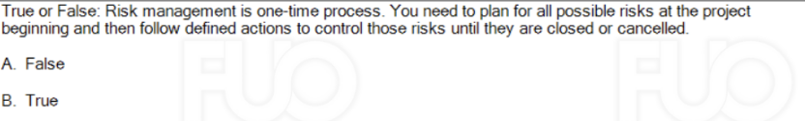A. False**

**Q20 True or False: Your role as the project manager during quality assurance is to implement the quality management plan using the appropriate tools and techniques, in order to ensure that work is being performed according to required quality standards**

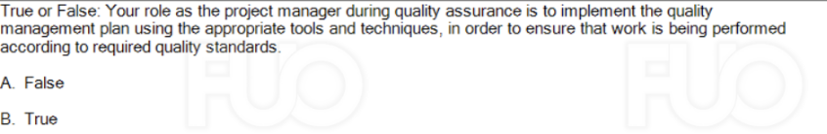

**B. True**

**Q21 You have finished planning and have begun executing the project when the client asks if you would add some important features to the product of the project. How are the triple constraints affected?**

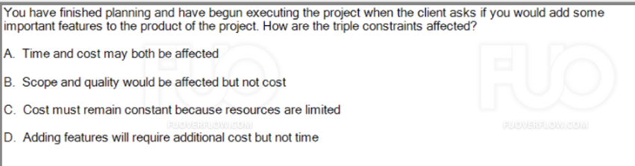

**A. Time and cost may both be affected**

**Q22 Your stakeholder register should not contain:**

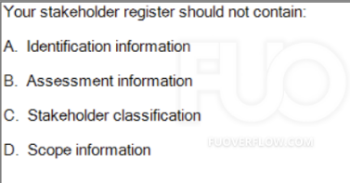

**D. Scope information**

**Q23 Operational work is different from project work in that operational work is:**

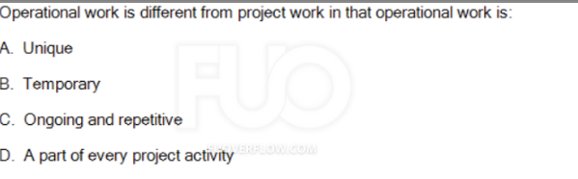

**C. Ongoing and repetitive**

**Q24 Which one of these most correctly defines management reserve?**

**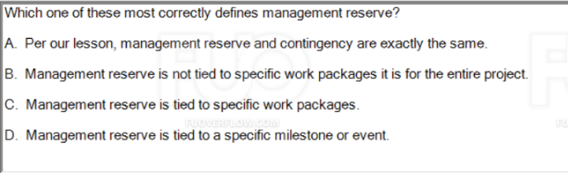  
B. Management reserve is not tied to specific work packages it is for the entire project.**

**Note:**

**contingency reserve = > tied to specific management reserve => not tied to**

**Q25**

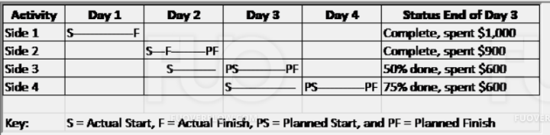

**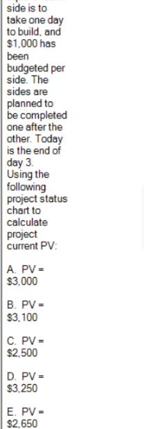  
A. PV = $3,000  
Dựa vào bảng bên trên thì thằng side 4 cần đến 4 ngày để hoàn thành nên PV chỉ tính 3 thằng side 1, side 2 ,side 3 vào số tiền mỗi side được bỏ ra là 1000$**

**Q26 As discussed in the Project Management course, The PMBOK® Guide describes 10 Project Management Knowledge Areas. Identify 3 out of the 10:**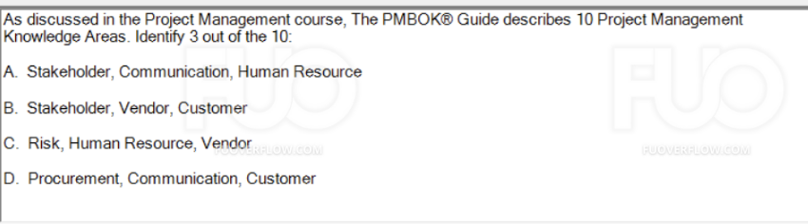

**A. Stakeholder, Communication, Human Resource**

**Q27 True or False: Authority means you have the right to apply resources, make decisions and give approvals.**

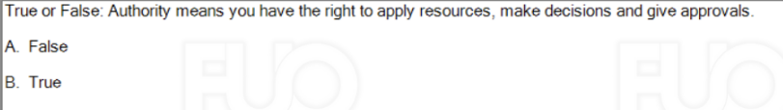

**B. True**

**Q28 True or False: The critical path is the shortest path through the network and represents the work that can be delayed without delaying the end of the project.**

**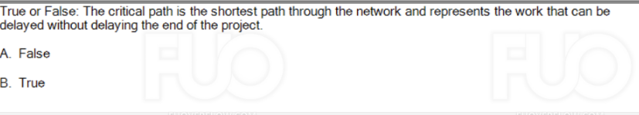  
A. False**

**The critical path is the longest path through the network and represents the work that cannot be delayed without delaying the end of the project.**

**Q29 Which of the following best describes the project manager's role as an integrator?**

**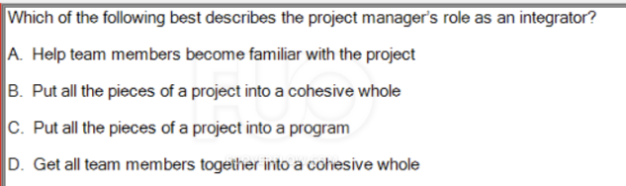   
B. Put all the pieces of a project into a cohesive whole**

**Q31 Which one of these is not the approaches to conflict discussed in the Project Human Resources Management Lesson?**

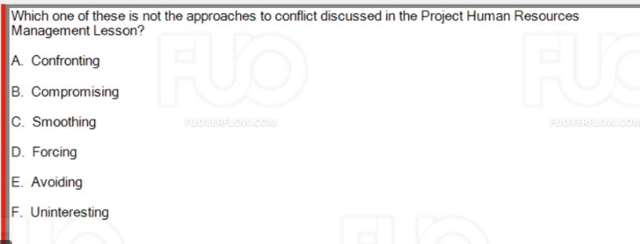

**F. Uninteresting**

**Q34 Considering a situation in which you need to share an important announcement with your project team. Select the best communication option for the scenario:**

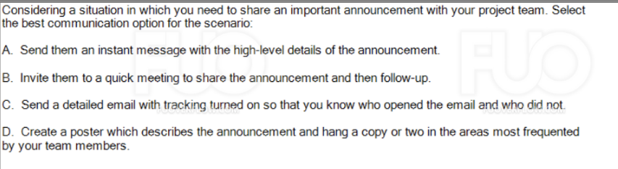

**B. Invite them to a quick meeting to share the announcement and then follow-up.**

**Q39 When you have good historical information which can be used in a reliable formula or model, you will probably use:**

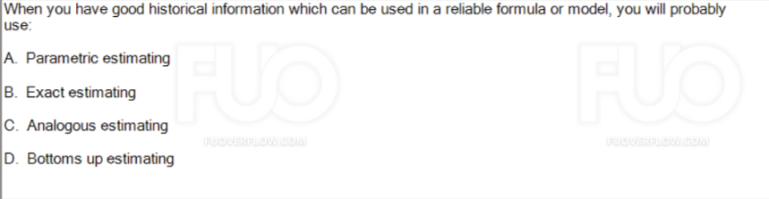

**A. Parametric estimating**

**Q40 To calculate late finish (LF) of an activity which has only one successor, you will  
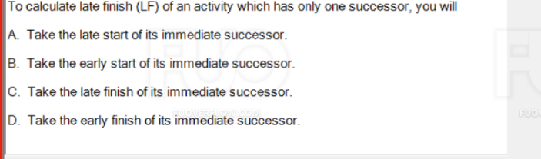**

**A. Take the late start of its immediate successor.**

**Q41 Your Schedule Performance Index (SPI) is greater than 1 means you are:**

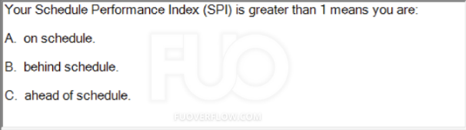

**C. ahead of schedule.**

**Q42 Which process group focuses on completing the requirements of the project?**

**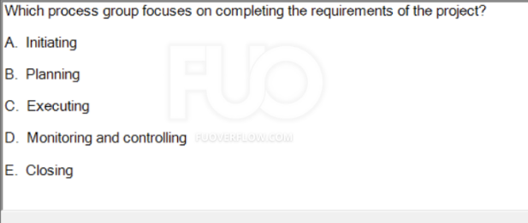  
C. Executing**

**Q43 True or False: The worst organization to use to run a project will always be the functional organization.**

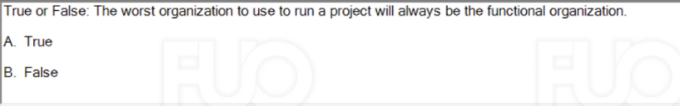

**B. False**

**Q44 Which of the following is true about the development of a project charter?**

**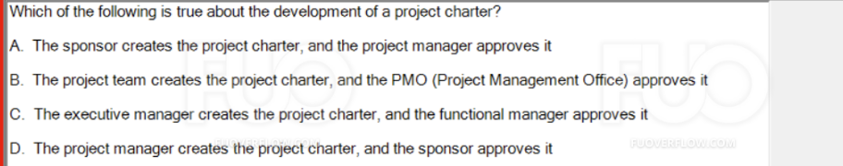  
D. The project manager creates the project charter, and the sponsor approves it**

**Q45 When you use the RACI or Responsible, Accountable, Consult, Inform version of the RAM, those consulted persons are:  
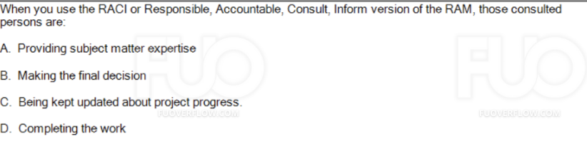**

**A. Providing subject matter expertise**

**Q46 Which of the following is NOT the output of Plan Scope Management process? (Choose 2 answers)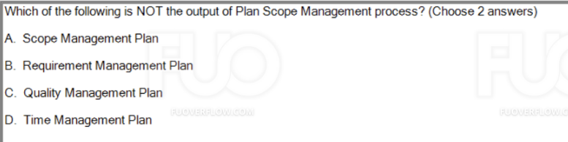  
C. Quality Management Plan**

**D. Time Management Plan**

**Q47 True or False: Project Cost Management processes aim to help the project can be completed within the approved budget.  
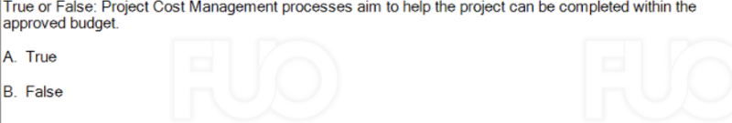**

**A. True**

**Q49 (Choose 2 answers)**

**Different estimating techniques serve different purpose, which of the following statements are correct**

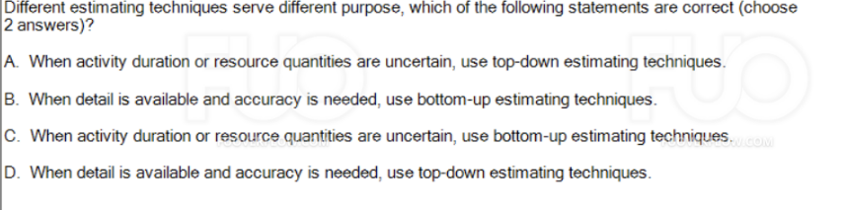

**A. When activity duration or resource quantities are uncertain, use top-down estimating techniques.**

**B. When detail is available and accuracy is needed, use bottom-up estimating techniques.**

**activity => top-down**

**details => bottom-up**